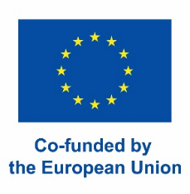
APPLICATION

Summer School: European Education Week
July 29 – August 03, 2024

1. PERSONAL DATA

Name

First Name

Date of Birth
Nationality
Gender | ☐ Female ☐ Male ☐ Other
Passport/ID Number
Home Address

Email
Mobile Number
2. ACADEMIC DATA

University
at which you are currently enrolled
Degree
- Bachelor / Master
- of Education/Sciences/Arts...
Name of Study Program

Number of completed semesters
Studied subjects

Language Skills and Level  English Language Skills are a prerequisite for participation. | Please tell us how you rate your English Language Skills on the level of:  A1-A2 ☐ I am native speaker ☐  B1-B2 ☐  C1-C2 ☐
Course during European Education Week | Please let us know in which course you would like to participate (you can only participate in one course).  Please assign priorities 1 (first choice) – 2 (second choice).  Course Title Priority  A Ethical arguments in the Debate on Sustainable Development  B Mindfulness in Teacher and Student Education
Additional remarks:

3. COSTS FOR TRAVELLING AND HOUSING

Participants from partner universities of the project “UNI-T Academy” can receive a travel and accommodation grant according to ERASMUS+ fares. The grants vary for different countries.
Participants are provided housing in shared rooms (2-4 beds) with other participants.
All rooms are within walking distance to the university.
4. COMPLETE YOUR APPLICATION

Please hand in these documents via email: | - The document ‘Application_Summer School_ International Education Week 2024’  - The document ‘CV_Motivation_Education_Week_Summer_School_2024’  - A copy of the ‘Confirmation of Enrolment’ from your university (including your student number)
5. PROCEEDINGS: ACCEPTANCE AND CONFIRMATION

Letter of Acceptance | Successful applicants will be informed by beginning of May 2024.
Confirmation of Participation | Confirm your participation by signing the Subsidy Agreement until May 15, 2024.
6. TERMS AND CONDITIONS

The application deadline for the European Education Week is April 20, 2024. Applications after this date can only be considered if there are still places available.
The program includes the respective courses, social and cultural activities and accommodation. Country-specific travel grants are available for applicants from within the geographic region of Europe.
Acceptances or rejections will be confirmed after the application deadline.
The program does not include any insurance coverage in case of illness, accident, personal damage or damage to property. Participants must provide their own health, accident and liability insurance.
Participants will not be enrolled as students of the University of Tübingen.

I wish to participate in the European Education Week and I accept the terms and conditions as stated above.
Date, Signature

Please contact us for any questions: education-week@tuese.uni-tuebingen.de
We are looking forward to welcome you in Tübingen!

Kind regards,

The Education Week Project Coordination
Annika Böcker & Deborah Diekmann

Visit us at https://uni-tuebingen.de/de/95235

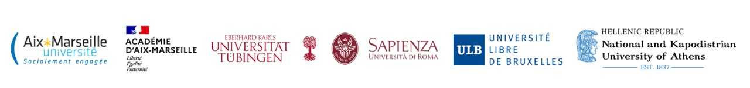
Co-funded by the European Union. Views and opinions expressed are however those of the author(s) only and do not necessarily reflect those of the European Union or the European Education and Culture Executive Agency (EACEA). Neither the European Union nor EACEA can be held responsible for them.

