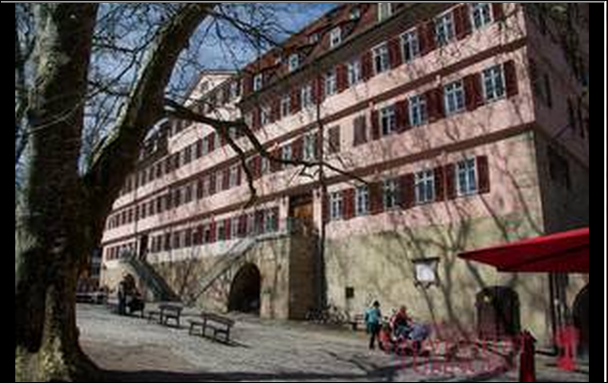
© Universität Tübingen

D TUBINGE01: University of Tuebingen
Annex to Erasmus+ Inter-Institutional Agreement
Institutional Factsheet
- Institutional Information
  - Institutional details
Name of the institution | University of Tuebingen
Erasmus Code | D TUBINGE01
EUC | 29861-LA-1-2014-1-DE-E4AKA1-ECHE
Institution website | http://www.uni-tuebingen.de/en/international/international-students-in-tuebingen.html
Online course catalogue | http://www.uni-tuebingen.de/en/international/study-in-tuebingen/programs-and-modules-for-international-students.html

  - Main contacts
Contact person | Dr. Kordula Glander
Responsibility | Erasmus Institutional Coordinator
Contact details | k.glander@uni-tuebingen.de

Contact person | Simone Hahne M.A.
Responsibility | Admissions of incoming students
Contact details | simone.hahne@verwaltung.uni-tuebingen.de

Contact person
Responsibility | Erasmus Departmental Coordinator
Contact details

- Detailed requirements and additional information
  - Recommended language skills
The sending institution, following agreement with our institution, is responsible for providing support to its nominated candidates so that they can have the recommended language skills at the start of the study or teaching period:

Type of mobility | Subject area | Language(s) of instruction | Recommended language of  instruction level *
Student Mobility for Studies |  | German | B1
Staff Mobility for Teaching |  | German, English | B2
* Level according to Common European Framework of Reference for Languages (CEFR), see
http://europass.cedefop.europa.eu/en/resources/european-language-levels-cefr

For more details on the language of instruction recommendations, please refer to our course catalogue.

  - Additional requirements
http://www.uni-tuebingen.de/en/study/information-and-advice/disabled-students.html
  - Calendar
    - Nomination Deadlines
Applications/information on students nominated must reach our institution by:

Autumn term | May 31st | https://www.service4mobility.com/europe/BewerbungServlet?identifier=TUEBINGE01&sprache=de&kz_bew_pers=S&kz_bew_art=IN
Spring term | December 31st

    - Decision Response
We will send our decision within May 1st and June 15th (for the winter term) and between November 1st and January 15th (for the summer term).

    - Transcripts of Records
A Transcript of Records will be issued no later than 8 weeks after the assessment period has finished at our institution.

    - Termination of Agreement
The University of Tuebingen agrees on the procedure for modifying or terminating the inter-institutional agreement. However, in the event of unilateral termination, a notice of at least one academic year should be given. This means that a unilateral decision to discontinue the exchanges notified to the other party by 1 September 20XX will only take effect as of 1 September 20XX+1. Neither the European Commission nor the National Agencies can be held responsible in case of a conflict.

- Additional information
  - Grading system
1,0/ 1,3/ 1,5  1,7/ 2,0/ 2,3/ 2,5  2,7/ 3,0/ 3,3/ 3,5  3,7/ 4,0  5 | sehr gut / very good  gut / good  befriedigend / satisfactory  ausreichend/ adequate  ungenügend / inadequate

  - Visa
Our institution will provide assistance, when required, in securing visas for incoming and outgoing students/staff, according to the requirements of the Erasmus Charter for Higher Education.
Information and assistance can be provided by the following contact points and information sources:

Contact person | Simone Hahne
Responsibility | Admissions
Contact details | simone.hahne@verwaltung.uni-tuebingen.de

  - Insurance
Our institutions will provide assistance in obtaining insurance for incoming and outgoing students/staff, according to the requirements of the Erasmus Charter for Higher Education.

We will inform incoming students/staff of cases in which insurance cover is not automatically provided. Information and assistance can be provided by the following contact points and information sources:

Contact person | Simone Hahne
Responsibility | Admissions
Contact details | simone.hahne@verwaltung.uni-tuebingen.de

  - Housing
Our institution will guide incoming student/staff in finding accommodation, according to the requirements of the Erasmus Charter for Higher Education. Information and assistance can be provided by the following persons and information sources:

Contact person | Melanie Mattes
Contact details | melanie.mattes@sw-tuebingen-hohenheim.de
Website | https://en.my-stuwe.de/housing/

