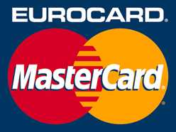 MAIL ORDER CREDIT CARD INVOICE

Office / Phone no: / At events: Duration from to
Booking: cost center , fund , WBS element or internal order , general ledger account

No. | Name of payer | Credit card no. | CVC | Valid thru: | Amount in EUR
1
2
3
4
5
6
7
8
9
10
 |  |  |  | Total: | 0.00
To the Universitätskasse Tübingen for processing!
Tübingen, 02.12.20

_________________________________

Please note: Customers may communicate their credit card details by letter, fax, or phone only. The data on this form may be forwarded to the Universitätskasse by internal mail or by fax (+49 7071 295202) only. It is forbidden to require, receive, or transfer credit card data via the internet (including email) because a liablity for damages arises if the credit card data are misused!

