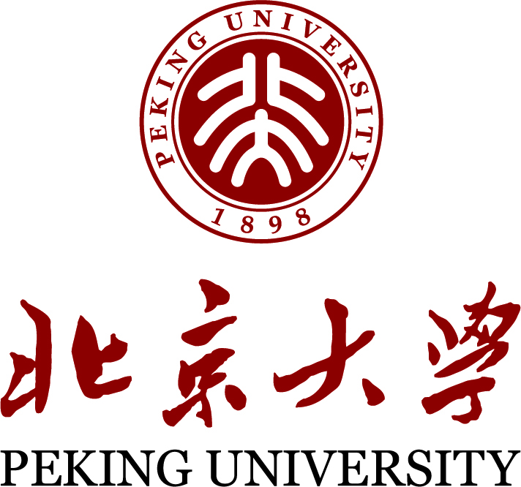
Peking University Exchange International
Fact Sheet Academic Year 2023-2024

CONTACT
Name of institution | Peking University, CHINA
Inbound Coordinator for University Exchange Program | KAN Ping (Ms.)  Programme Officer, International Students Division,  Office of International Relations  Address: Room 328, New Sun Student Center, Peking University, No.5 Yiheyuan Road, Haidian District, Beijing, China 100871  Tel: +86 10 62752611  Fax: +86 10 62751233  Email: exchange@pku.edu.cn
Outbound Coordinator for University Exchange Program | WANG Shuo (Ms)  Programme Officer, Division for Study Abroad Program (EAP),  Office of International Relations  Address: Room 101, Nan Ge, Peking University, No.5 Yiheyuan Road, Haidian District, Beijing, China 100871  Tel: +86 10 62751244  Fax: +86 10 62751240  Email: pkueap@pku.edu.cn
International Student Division, responsible for all kinds of regular international student service and administration. | International Students Division(ISD), Office of International Relations  Address: 3rd Floor, New Sun Student Center, No.5 Yiheyuan Road, Haidian District, Beijing, China 100871
Long-term programs, including visiting student program (Room 330)
Tel: 86-10-62751230
Fax: 86-10-62751233
Email: study@pku.edu.cn
Short-term programs, including summer schools (Room 335)
Tel: 86-10-62757362
Fax: 86-10-62759754
Email: shortterm@pku.edu.cn

WEBSITE
Peking University | http://english.pku.edu.cn/
Office of International Relations | http://www.oir.pku.edu.cn/en/
International Students Division | http://www.isd.pku.edu.cn/
All courses at undergraduate level | http://www.dean.pku.edu.cn/service/web/courseSearch.php

ACADEMIC CALENDAR (below takes AY 2022-2023 for instance. Updated version to come out)
AY 2023-2024 Autumn Semester / term one
Start date | September 5, 2023 | End date | January 9, 2024
AY 2023-2024 Spring Semester / term two
Start date | February 20, 2024 | End date | June 26, 2024
*Calendar 2022-2023: https://www.pku.edu.cn/detail/2686.html

APPLICATION INFORMATION
Nomination deadline | For exchange in Autumn semester: March 30, 2023  For exchange in Spring semester: October 30, 2023
Nomination method | - Nomination Letter containing these information of students:  Full Name, nationality, gender, level, exchange period, email, study program  Notes:  Level: bachelor, master or doctor during the time of exchange;  Exchange period: autumn semester, spring semester or one academic year;  Study program: current study program at home university.  - Official paper nomination letter is also required.
Online application period | For exchange in Autumn semester: Feb. 20-April 15, 2023  For exchange in Spring semester: Sep. 20-Nov. 15, 2023
Application procedure | Step 1: Official nomination by the home university;  Step 2: Nominated applicants must complete PKU online application (http://www.studyatpku.com) and submit the ORIGINAL hard copies (English version) to the international office at home university;  Step 3: International office at home university should check and send the hard copies to us within the designated date.
Supporting documents | Please refer to the “Application Information” to be sent by us before application system is open.
When will successful applicants be notified? | For exchange in Autumn semester: late May, 2023  For exchange in Spring semester: late December, 2023
Proof of language level | For studying Chinese: no language level required.  For Chinese-taught undergraduate/graduate courses: Chinese HSK 6 (with each item over 70 points) or equivalent level.  English is not required at the application process. Certain courses may require students to submit language proof or take test.
Student status | 1. At least finish the first year of current study program before the time of exchange;  2. Remain registered at home university during the exchange period;  3. Students in the graduate year at home university are NOT recommended to apply;  4. Applicants must be NONE-CHINESE citizens with a valid ordinary passport, above the age of 18 and under the age of 45.
Application language | English or Chinese
Language of instruction | Mainly Chinese at undergraduate and master level.  Some English courses are available.  For details, please refer to COURSE INFORMATION below.

COURSE INFORMATION
Compulsory workload for one semester (16 weeks) | - For students mainly taking Chinese language training courses: minimal 18 class hours/week( 2-5 courses);  - For students giving up Chinese language learning and only taking undergraduate/graduate courses: 6-20 credits (2-10 courses) in total, normally: 1 credit= 1 class hour of attendance, 1 course demands 2, 3 or 4 class hours per week, in total 32, 48, or 64 hours per semester.
Course information | 1.For Chinese language training courses, please refer to the “General Information on PKU Chinese Language Training Courses” sent together with the Fact Sheet.  2. For undergraduate courses: please check at http://www.dean.pku.edu.cn/service/web/courseSearch.php  When using the website, please note:  - Most courses are taught in Chinese. The specific list of English-taught courses will be provided around middle January/July before course registration starts.  - Courses may change and school/department reserves the right to enroll a student to certain course.
How and when will courses be publicized? | Check the course information of the next semester on the above website in middle January/July.
How and when do students register for courses? | - Chinese language training courses at School of Chinese as a Second Language: course allocation (elementary, intermediate or advanced) will depend on the result of the pre-arrival online self-assessment on Chinese language proficiency and the face-to-face interview in the orientation week;  - Undergraduate/graduate courses: select courses online after registration.  - The school and department reserve the right to register students into certain course depending on programs and course availability.
Courses are NOT available in these faculties/programs | - Health Science Center  - School of Software and Microelectronics  - Faculty with special pre-requisites  - Tailor-made programs  - Double-degree courses  - Shenzhen Graduate School (case-by-case discussion is needed)  - English-taught graduate courses of special Master programs (MBA, Master in International Relations, Master in Public Policy, LLM in Chinese Law, Yenching Academy, etc.)  - Chinese-taught Master-level courses are only available with the faculty’s permit
Transcript/ Study certificate | We will send official transcripts to the international office of home university at the beginning of next semester (late September/ middle March).  If a student needs an extra copy or a study certificate, he or she can consult ISD in early January/late June. For extra copies, they need to pay a minor fee.

ACCOMMODATION
Please check first with home university whether the bilateral student exchange agreement covers free accommodation. If it does, your room will be automatically allocated in the Global Village upon arrival, shared with another international student. There is no independent bathroom in the dorm, but there is bathroom on each floor. Any special requests must be addressed directly to Global Village upon check-in.
For those whose accommodation is not covered by PKU, they can either apply dormitory on campus (if available) or rent an apartment off campus.
Dormitory on campus | PKU offers many dormitory types to international students: the Global Village (Zhong Guan Xin Yuan). The monthly rent is around 3300-4500 Yuan.  Online dorm booking will start in mid July/mid January at http://www.studyatpku.com . Please pay close attention to the latest notice at www.isd.pku.edu.cn
Off campus housing | Off campus housing offers more choices in room type and the monthly rent ranging from 2000-5000 Yuan. Local agents offers more information, for example, the following agents provide English service: https://intl.ziroom.com/  http://www.beijingbuddy.com
Website: http://www.isd.pku.edu.cn

COSTS
Living cost | Ranging from 1000 - 3000 Yuan RMB per month depending on individuals; Students can survive with every little cost on campus which provides basically everything including food, grocery, laundry, books, internet, etc.
Accommodation | Ranging from 2500-5000Yuan RMB per month depending on location and room condition.
University fee | Normally exchange students do not pay any application, tuition or administrative fees as per the university bilateral agreement.
Local Transportation | Public transportation is as cheap as 2 Yuan for bus, less than 10 Yuan for subway.
Insurance | Exchange students MUST purchase the designated medical insurance plan in China for a cost of 400 Yuan RMB per semester.

MORE INFORMATION
More information will come along with the “Application Instructions” during the application period and “PKU International Student Guide” book after admission.

