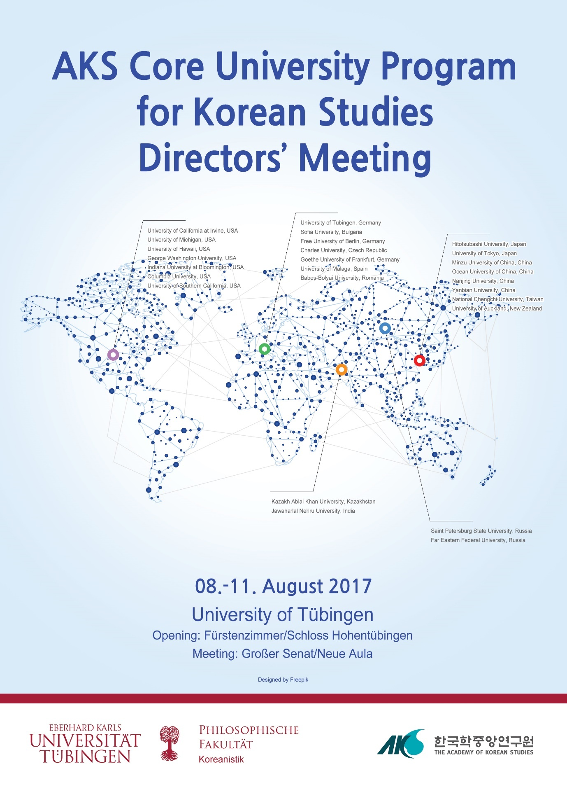

AKS Core University Program for Korean Studies
Directors’ Meeting
August 8-11, 2017
University of Tübingen, Germany
Language: English / Korean

About
Korean Studies is a fast-growing academic field, and the time is ripe for researchers to look back on their achievements and to probe future possibilities for Korean Studies as a discipline or a research field. Thus, this Forum has three aims:
- To establish an international cooperative network among directors of the Core University Program for Korean Studies and create overseas Korean Studies infrastructure by sharing state of educational programs and research outcomes.
- To amplify the synergy among researchers of the Core University Program for Korean Studies by sharing of strategy, information, and research outcomes, and, hence, enhance the quality of Overseas Korean Studies.
- To find more sound program processes through understanding of both Korean Studies support policies and each research unit’s opportunities and constraints.
Furthermore, through this Forum, we want to secure a long-term cooperative network among the project leaders, and to share the opportunities and constraints that have emerged during the course of their projects. These will be used for a more objective evaluation process as well as to help in development planning for each project in the Core University Program. For this purpose, we plan to make conference proceedings that will consist of an analysis of each project of the Core University Program represented at the 2017 meeting. This will provide future participants with important implications of program designs and contents, hence greatly assisting in their future planning. Thus, we anticipate that each program director will provide a general overview and analysis of their respective project.

Program

OPENING: Tuesday, August 8, 2017
@ Venue: Fürstenzimmer / Schloss Hohentübingen (Tübingen Castle)
OPENING
Moderator: Jun-Prof. Dr. Jong-Chol An, University of Tübingen
18:00-18:15
- Opening:
Prof. Dr. You Jae Lee (Director of Korean Studies, University of Tübingen)
- Welcoming Remarks:
Prof. Dr. Dr. h.c. Bernd Engler (Rector of the University of Tübingen)
Dr. Bumhym Bek (Consul-General of the Republic of Korea, Frankfurt a.M.)
Prof. Dr. Jongmyung Kim (Director of Korean Studies Promotion Service, AKS, Seongnam)
18:15-19:00
- Keynote Speech:
Connecting Korea and the World via Korean Studies
Prof. Dr. Myoung-Kyu Park (Seoul National University)
19:30-21:30
- Dinner Reception:
Restaurant Forelle, Kronenstraße 8, 72070 Tübingen
* * *

DIRECTORS' MEETING: Wednesday, August 9, 2017
@ Venue: Großer Senat / Neue Aula
SESSION I: Korean Studies in Europe
Moderator: Jerôme de Wit, University of Tübingen
09:00-10:30
- Global Korea: Colonialism, Cold War, and Migration
You Jae Lee (University of Tübingen, Germany)
- Enlargement of Korean Studies Disciplinary Field at Saint-Petersburg University and Development of Northern and Eastern European Korean Studies Network
Rimma K. Tangalycheva (Saint Petersburg State University, Russia)
- 불가리아의 한국학 정착과 확산을 위한 교육·연구 통합시스템 구축
Soyoung Kim (Sofia University, Bulgaria)
10:30-10:45 Coffee Break
10:45-11:45
- Transcoding as a Cultural and Social Practice
Eun-Jeung Lee (Free University of Berlin, Germany
- Beauty of Korean Tradition from Interdisciplinary Perspective
Miriam Löwensteinová (Charles University, Czech Republic)
11:45-14:00 Lunch Break

SESSION II: Korean Studies in North America
Moderator: Taejin Hwang, University of Tübingen
14:00-16:00
- UCI Center for Critical Korean Studies
Kyung Hyun Kim (University of California at Irvine, USA)
- Visioning Korea for the Next Generation: Korean Studies in the Classroom
Nojin Kwak (University of Michigan, USA)
- Korean Studies in North America: Challenges and Future Vision
Sang-Hyop Lee (University of Hawaii, USA)
- Korean Humanities in the Nation’s Capital, Washington, DC.
Jisoo M. Kim (George Washington University, USA)
16:00-16:15 Coffee Break
16:15-17:45
- Establishing Korean Studies in America’s Heartland
Seung-kyung Kim (Indiana University at Bloomington, USA)
- CKR as Regional, National, and Global Korean Studies Hub
Jungwon Kim (Columbia University, USA)
- Establishment of a Leading Center for Korean Studies in the Social Sciences
Gloria Koo (University of Southern California, USA)
18:00-21:00
- Dinner:
Restaurant Die Kelter, Schmiedtorstraße 17, 72070 Tübingen

* * *

DIRECTORS' MEETING: Thursday, August 10, 2017
@ Venue: Großer Senat / Neue Aula
SESSION III: Korean Studies in Asia I
Moderator: Tobias Scholl, University of Tübingen
09:00-10:30
- Korean Studies in Central Asia
Nelly Pak (Kazakh Ablai Khan University, Kazakhstan)
- Promotion of Korean Studies in Far Eastern Russia: Successes and Challenges
Marina Kukla (Far Eastern Federal University, Russia)
- Korean Studies in India and South Asia
Ravikesh (Jawaharlal Nehru University, India)
10:30-10:45 Coffee Break
10:45-11:45
- In Search for Historical Rapprochement-Experience, Memory, and Coexistence
Yeounsuk Lee (Hitotsubashi University, Japan)
- Advantages and Difficulties of Korean Studies in Japan
Tadashi Kimiya (University of Tokyo, Japan)
11:45-14:00 Lunch Break

SESSION III: Korean Studies in Asia II
Moderator: Sungjo Kim, University of Tübingen
14:00-15:30
- 북경지역 한국학 교육 연구 강화 및 다민족 대상 한국학 교육 시스템 구축
Chun-Xian Jin (Minzu University of China, China)
- 중국내 한국학 정착을 위한 선택과 집중의 한국학교육연구시스템 구축
Hai-Ying Li (Ocean University of China, China)
- 난징대학교의 ‘인문한국학’ 교육·연구
Hai-Yan Yin (Nanjing University, China)
15:30-15:45 Coffee Break
15:45-16:45
- Reconstruction of Korean Studies in China
Can-Kui Piao (Yanbian University, China)
- 대만에서의 한국학 발전 현황
Qing-Zhi Chen (National Chengchi University, Taiwan)
18:00-19:00 Boat Tour on the Neckar River
19:00-21:00 Dinner: Restaurant Bootshaus, Wöhrdstraße 25, 72072 Tübingen
* * *

DIRECTORS' MEETING: Friday, August 11, 2017
@ Venue: Großer Senat / Neue Aula
SESSION IV: AKS Seed Projects
Moderator: You Jae Lee, University of Tübingen
09:00-10:20
- Consolidating Frankfurt Korean Studies Through Teaching and Research on “Identity and Transnational Mobility in and out of Korea”
Yonson Ahn (Goethe University of Frankfurt, Germany)
- Korean Studies from an Intercultural Perspective: Creation and Development of Korean Studies at the University of Malaga
Antonio José Doménech del Río (University of Malaga, Spain)
- Korean Studies at Babeș-Bolyai University, Romania: Past Development and Future Prospects
Codruta Sintionean (Babeș-Bolyai University, Romania)
- Korean Studies in New Zealand: Growth Strategy
Changzoo Song (University of Auckland, New Zealand, former AKS Core University)
10:20-10:35 Coffee Break

FINAL DISCUSSION: Korean Studies in the Future
Moderators: Jong-Chol An, University of Tübingen / Jongmyung Kim, Academy of Korean Studies
10:35-12:00
- Research Trends, Networking, and Promotion Policies
12:00-13:15 Lunch
13:30-17:00 Optional Field Trip:
Bebenhausen Monastery and Palace, Im Schloß 1, 72074 Tübingen [Bus 828]

Venues
- August 8, 2017:
Fürstenzimmer
Schloss Hohentübingen (Tübingen Castle)
Burgsteige 11, 72070 Tübingen
- August 9-11, 2017:
Großer Senat
Neue Aula
Geschwister-Scholl-Platz 7, 72074 Tübingen

Contact
- Director of the Tübingen Global Korea Project:
Prof. Dr. You Jae Lee (lee@aoi.uni-tuebingen.de).
- Person in Charge of the Meeting:
Jun.-Prof. Dr. Jong-Chol An (jong-chol.an@uni-tuebingen.de).
- For more information and questions, please contact:
Dr. Tobias Scholl (tobias.scholl@uni-tuebingen.de)

The AKS Core University Program for Korean Studies Directors’ Meeting is organized by the Department of Korean Studies at University of Tübingen and supported by the Academy of Korean Studies
Department of Korean Studies, Wilhelmstr. 133, 72074 Tübingen, Germany
www.korea.uni-tuebingen.de

Hotel Information
Hotel Krone Tübingen
Uhlandstraße 1, 72072 Tübingen, Germany
Telephone +49 7071 1331-0
Email info@krone-tuebingen.de
http://www.krone-tuebingen.de/en/index.htm

