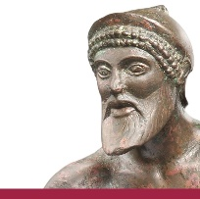
XXth International Congress on Ancient Bronzes
17.04. - 21.04.2018
Institute for Classical Archaeology Tübingen
Registration Form

Name:
Address:
E-Mail:
Affiliation:

Participation:
- Reception: ☐yes ☐no

- Conference Dinner: ☐yes ☐no

- Excursion: ☐yes ☐no
Landesmuseum Württemberg: €20
Including transfer to Stuttgart, a small lunch bag, a guided tour through the museum and a transfer back to Tübingen.

Conference fee: The conference fee of €100 can be payed via bank transfer
Bank: BW-Bank Tübingen
Beneficiary: Universität Tübingen
IBAN: DE24 6005 0101 7477 5036 14
BIC: SOLADEST600
Reference/Purpose: Bronze Congress and your Name

The fee includes a conference bag, the reception, lunch snacks, coffee breaks (tea and coffee) and the conference dinner (drinks not included).

Please send this registration form to: AncientBronzes2018@klassarch.uni-tuebingen.de

