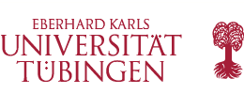
Englisches Seminar – Wilhelmstraße 50 – 72074 Tübingen – Raum 363

ERASMUS+ Personal Statement

Guidelines
Please explain your motivation for studying abroad in no more than 300 words. (Use the text box below). Sign the document and send it to erasmus@es.uni-tuebingen.de along with all other necessary documents as one PDF file (see document “ERASMUS+ Application Information”).

Application deadline: 20th December 2024, 23:59h

You may consider these guiding questions:
- What motivates you, and what is your greatest strength?
- What are your interests (subject specific and extra-curricular)?
- How will you benefit from a year/semester abroad (other than improving your language skills)?

Name: .....................................................................

..................................................................... .....................................................................
Place + Date Signature

