Style sheet screenshot:
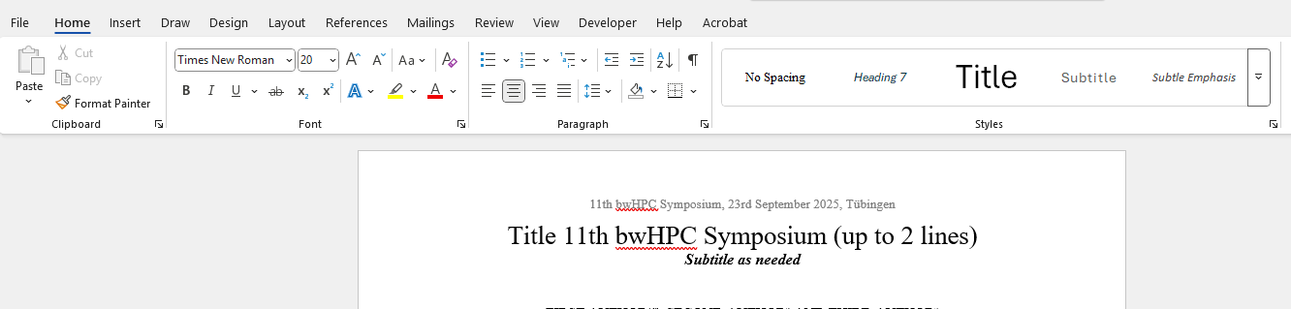
Click the dropdown

