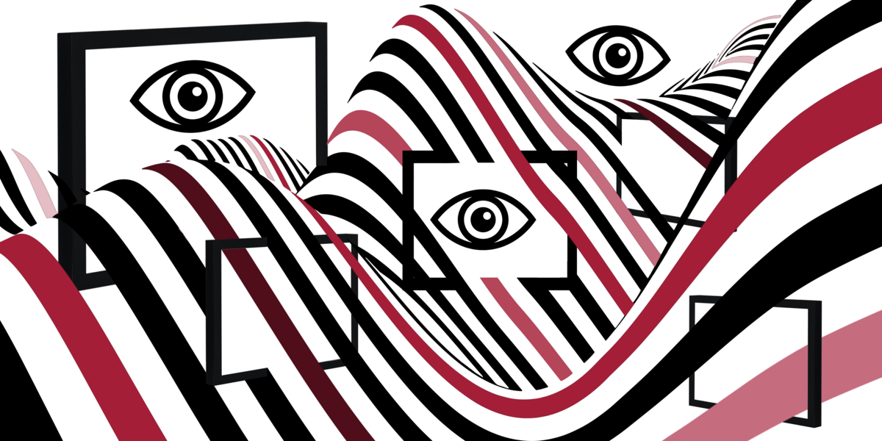
Selected extended abstracts from the conference:
Images in Motion and Moving Images:
Gender, Power & Mobility
19th – 21st November 2025, Tübingen,
Joint conference of the DGPuK Divisions
„Media, Public Sphere, Gender“ and „Visual Communication“

Paper Title (title case, 14 pt ARIAL Bold)

A. B. Author (upper & lower case, 12 pt Times New Roman Regular)
A. B. Author Institution

C. D. Author (upper & lower case, 12 pt Times New Roman Regular)
C. D. Author Institution

Keywords: Times New Roman Regular, size 12.

Section Header(s) (upper & lower case, 12 pt ARIAL Bold)

Format requirements for the body of the submission are as follows: Times New Roman font, size 12, single-spaced, justify text throughout, double-spaced for new paragraphs. The language of the abstract submission should be English or German throughout.

New paragraph starts like this, an extra space from the previous, no indent. If submitting a panel, simply repeat this formatting - minus the letterhead - sequentially for each paper on the panel.

Word limits:
- 1500 for extended abstracts. References and figures are not part of the word count.
- 600 for an introductory statement for panel submission.

References

References should be formatted the same as the body but left-aligned: with a double space between entries. Times New Roman font, size 12, single space

Only the APA standard style guide (7th edition) is acceptable for formatting the references: https://apastyle.apa.org/style-grammar-guidelines.

