Topic: Blogs for Final Exam

Indigenous Media and Media Sovereignty from U-Matic to YouTube. What Next?

“It’s complicated”: Is the demotional demotion just a click away?

Name: Aishwarya Sunil Bagal
Course: Introduction into Anthropology of Media
Taught by: Gulzat Baialieva
Matriculation Number: 5963779

I. Indigenous Media and Media Sovereignty from U-Matic to YouTube. What Next?

The media content produced from, with, or for indigenous people can rightly be categorised as indigenous media. It could be said that indigenous media first came into existence in the 1980s. The movie Pocahontas, released in the year 1995, was my first ever introduction to indigenous lives. I have watched that film as a child and enjoyed the fairytale-like story of Pocahontas, but it is only now that I realise the brevity of the movie. Although the movie poster claimed it to be “An American Legend Comes To Life”, did it really do justice to the Natives?
A simple Venn diagram to suggest the definition of Indigenous Media

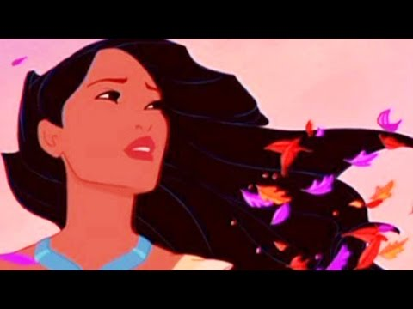
The Song “Colours Of The Wind” As Picturized In The Movie Pocahontas (1995)
Source: https://www.youtube.com/watch?v=O9MvdMqKvpU

source:https://www.google.com/search?q=nitv&rlz=1C1CHZL_enIN723IN723&sxsrf=AOaemvKdbZOsqRU9NSe0Dg3QF5yoAWPhCQ:1638317576545&source=lnms&tbm=isch&sa=X&ved=2ahUKEwi9hbfJqMH0AhUg7rsIHS2vCiYQ_AUoAXoECAEQAw&biw=1536&bih=754&dpr=1.25#imgrc=PnTFBQjeSIa6KM&imgdii=_Bn0m3c0F29p2M
https://www.google.com/search?q=Aboriginal+People%E2%80%99s+Television+Network+in+Canada&rlz=1C1CHZL_enIN723IN723&sxsrf=AOaemvKwXeHaY0j6d8ymqXPU7dACFhewjw:1638316890670&source=lnms&tbm=isch&sa=X&sqi=2&ved=2ahUKEwiNurCCpsH0AhU57rsIHRDpBtUQ_AUoAXoECAEQAw&biw=1536&bih=754&dpr=1.25#imgrc=SGfcZSljRhL6cM
https://www.google.com/search?q=maori+tv+in+new+zealand&tbm=isch&ved=2ahUKEwj6nZjhpsH0AhUKhaQKHUaQCL0Q2-cCegQIABAA&oq=maori+&gs_lcp=CgNpbWcQARgAMgcIIxDvAxAnMgUIABCABDIECAAQQzIFCAAQgAQyBAgAEEMyBQgAEIAEMgUIABCABDIECAAQQzIFCAAQgAQyBQgAEIAEUNICWNICYIkNaABwAHgAgAFSiAGCAZIBATKYAQCgAQGqAQtnd3Mtd2l6LWltZ8ABAQ&sclient=img&ei=IbymYbqJHoqKkgXGoKLoCw&bih=754&biw=1536&rlz=1C1CHZL_enIN723IN723#imgrc=K3nYkQdfbV-Y6M
https://www.google.com/search?q=taiwan+indigenous+television&rlz=1C1CHZL_enIN723IN723&hl=en&sxsrf=AOaemvJDfLkjOOmp1RsBCBNWv3ru_fvIOg:1638317187463&source=lnms&tbm=isch&sa=X&ved=2ahUKEwjgqfOPp8H0AhV8_rsIHRJ2DH0Q_AUoAXoECAEQAw&biw=1536&bih=754&dpr=1.25#imgrc=zrFHis4AwziFAM&imgdii=-NXohuAxNCrFSM

Indigenous media developed as a response to the entry of mass media in the lives of the First Nation people. Initially, it was represented by outsiders trying to articulate the voices of the natives. Even if it catered to the needs and requirements of the indigenous people, it failed to achieve its ultimate potential. On the contrary, it ignored and erased the interests and realities of indigenous lives and portrayed an outsider’s perspective. The sole purpose of the rise of indigenous media is to eradicate the power imbalance and articulating one’s own story in someone else’s words defeats the whole purpose.

Logos of Indigenous Television Channels. Source: Google images

source:https://www.google.com/search?q=nitv&rlz=1C1CHZL_enIN723IN723&sxsrf=AOaemvKdbZOsqRU9NSe0Dg3QF5yoAWPhCQ:1638317576545&source=lnms&tbm=isch&sa=X&ved=2ahUKEwi9hbfJqMH0AhUg7rsIHS2vCiYQ_AUoAXoECAEQAw&biw=1536&bih=754&dpr=1.25#imgrc=PnTFBQjeSIa6KM&imgdii=_Bn0m3c0F29p2M
https://www.google.com/search?q=Aboriginal+People%E2%80%99s+Television+Network+in+Canada&rlz=1C1CHZL_enIN723IN723&sxsrf=AOaemvKwXeHaY0j6d8ymqXPU7dACFhewjw:1638316890670&source=lnms&tbm=isch&sa=X&sqi=2&ved=2ahUKEwiNurCCpsH0AhU57rsIHRDpBtUQ_AUoAXoECAEQAw&biw=1536&bih=754&dpr=1.25#imgrc=SGfcZSljRhL6cM
https://www.google.com/search?q=maori+tv+in+new+zealand&tbm=isch&ved=2ahUKEwj6nZjhpsH0AhUKhaQKHUaQCL0Q2-cCegQIABAA&oq=maori+&gs_lcp=CgNpbWcQARgAMgcIIxDvAxAnMgUIABCABDIECAAQQzIFCAAQgAQyBAgAEEMyBQgAEIAEMgUIABCABDIECAAQQzIFCAAQgAQyBQgAEIAEUNICWNICYIkNaABwAHgAgAFSiAGCAZIBATKYAQCgAQGqAQtnd3Mtd2l6LWltZ8ABAQ&sclient=img&ei=IbymYbqJHoqKkgXGoKLoCw&bih=754&biw=1536&rlz=1C1CHZL_enIN723IN723#imgrc=K3nYkQdfbV-Y6M
https://www.google.com/search?q=taiwan+indigenous+television&rlz=1C1CHZL_enIN723IN723&hl=en&sxsrf=AOaemvJDfLkjOOmp1RsBCBNWv3ru_fvIOg:1638317187463&source=lnms&tbm=isch&sa=X&ved=2ahUKEwjgqfOPp8H0AhV8_rsIHRJ2DH0Q_AUoAXoECAEQAw&biw=1536&bih=754&dpr=1.25#imgrc=zrFHis4AwziFAM&imgdii=-NXohuAxNCrFSM

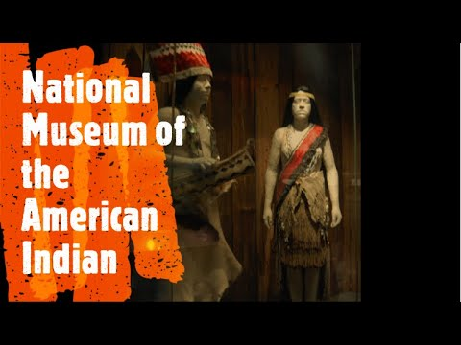
However, with the development of indigenous television, digital broadcasting, and indigenously directed feature films these challenges can gradually be conquered. The challenges don’t come to an end here. Preserving the collected data, artefacts, and photographs becomes a herculean task, especially when there are no funds and the popular demand asks otherwise. Fortunately enough, the natives now realise that it is time to take things into their own hands and understand the true sense of media sovereignty. Consequently, understanding media sovereignty gives them the power to control, govern, and represent themselves on the terms and conditions they want. It also leads to cultural activism that preserves ritual practices, local languages, historical knowledge, and brings a sense of autonomy along with a source of income that hopes to eliminate poverty and political oppression.

National museum of the american Indian’s film and video centre is one of the many supportive partnerships that help in preserving Indigenous Media
Source: https://www.youtube.com/watch?v=EqZqfaM-Fps

source:https://www.google.com/search?q=nitv&rlz=1C1CHZL_enIN723IN723&sxsrf=AOaemvKdbZOsqRU9NSe0Dg3QF5yoAWPhCQ:1638317576545&source=lnms&tbm=isch&sa=X&ved=2ahUKEwi9hbfJqMH0AhUg7rsIHS2vCiYQ_AUoAXoECAEQAw&biw=1536&bih=754&dpr=1.25#imgrc=PnTFBQjeSIa6KM&imgdii=_Bn0m3c0F29p2M
https://www.google.com/search?q=Aboriginal+People%E2%80%99s+Television+Network+in+Canada&rlz=1C1CHZL_enIN723IN723&sxsrf=AOaemvKwXeHaY0j6d8ymqXPU7dACFhewjw:1638316890670&source=lnms&tbm=isch&sa=X&sqi=2&ved=2ahUKEwiNurCCpsH0AhU57rsIHRDpBtUQ_AUoAXoECAEQAw&biw=1536&bih=754&dpr=1.25#imgrc=SGfcZSljRhL6cM
https://www.google.com/search?q=maori+tv+in+new+zealand&tbm=isch&ved=2ahUKEwj6nZjhpsH0AhUKhaQKHUaQCL0Q2-cCegQIABAA&oq=maori+&gs_lcp=CgNpbWcQARgAMgcIIxDvAxAnMgUIABCABDIECAAQQzIFCAAQgAQyBAgAEEMyBQgAEIAEMgUIABCABDIECAAQQzIFCAAQgAQyBQgAEIAEUNICWNICYIkNaABwAHgAgAFSiAGCAZIBATKYAQCgAQGqAQtnd3Mtd2l6LWltZ8ABAQ&sclient=img&ei=IbymYbqJHoqKkgXGoKLoCw&bih=754&biw=1536&rlz=1C1CHZL_enIN723IN723#imgrc=K3nYkQdfbV-Y6M
https://www.google.com/search?q=taiwan+indigenous+television&rlz=1C1CHZL_enIN723IN723&hl=en&sxsrf=AOaemvJDfLkjOOmp1RsBCBNWv3ru_fvIOg:1638317187463&source=lnms&tbm=isch&sa=X&ved=2ahUKEwjgqfOPp8H0AhV8_rsIHRJ2DH0Q_AUoAXoECAEQAw&biw=1536&bih=754&dpr=1.25#imgrc=zrFHis4AwziFAM&imgdii=-NXohuAxNCrFSM

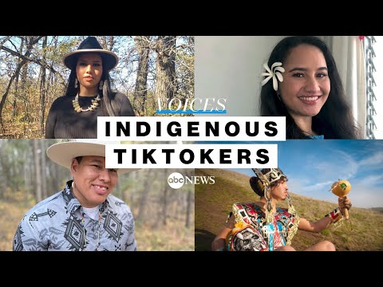
With the help from media archives, supportive partnerships, grants, and alliances, it becomes easier to overcome the pressing issues of preserving indigenous media in not only a sustainable but also technologically compatible manner in ways that are culturally and ethically relevant. As an anthropologist, it is important to play mediator between the two – the indigenous people and the others. On the one hand, the duty of an ethnographer is to evoke awareness that indigenous media exists and knowing of its existence is only going to enrich others’ lives, while on the other hand, it should be done in an unbiased manner. Although this was previously a tough nut to crack, digital rethinking has allowed us to step up the game. In fact, in the digital age of YouTube, Facebook, and TikTok, the awareness about social media platforms has given rise to the younger generations steering the winds of indigenous worlds according to their requirements and bringing serious issues that need attention into the limelight.
Indigenous TikTokers: The Real Voice
Source: https://www.youtube.com/watch?v=aAotqSHWzCY&t=144s

source:https://www.google.com/search?q=nitv&rlz=1C1CHZL_enIN723IN723&sxsrf=AOaemvKdbZOsqRU9NSe0Dg3QF5yoAWPhCQ:1638317576545&source=lnms&tbm=isch&sa=X&ved=2ahUKEwi9hbfJqMH0AhUg7rsIHS2vCiYQ_AUoAXoECAEQAw&biw=1536&bih=754&dpr=1.25#imgrc=PnTFBQjeSIa6KM&imgdii=_Bn0m3c0F29p2M
https://www.google.com/search?q=Aboriginal+People%E2%80%99s+Television+Network+in+Canada&rlz=1C1CHZL_enIN723IN723&sxsrf=AOaemvKwXeHaY0j6d8ymqXPU7dACFhewjw:1638316890670&source=lnms&tbm=isch&sa=X&sqi=2&ved=2ahUKEwiNurCCpsH0AhU57rsIHRDpBtUQ_AUoAXoECAEQAw&biw=1536&bih=754&dpr=1.25#imgrc=SGfcZSljRhL6cM
https://www.google.com/search?q=maori+tv+in+new+zealand&tbm=isch&ved=2ahUKEwj6nZjhpsH0AhUKhaQKHUaQCL0Q2-cCegQIABAA&oq=maori+&gs_lcp=CgNpbWcQARgAMgcIIxDvAxAnMgUIABCABDIECAAQQzIFCAAQgAQyBAgAEEMyBQgAEIAEMgUIABCABDIECAAQQzIFCAAQgAQyBQgAEIAEUNICWNICYIkNaABwAHgAgAFSiAGCAZIBATKYAQCgAQGqAQtnd3Mtd2l6LWltZ8ABAQ&sclient=img&ei=IbymYbqJHoqKkgXGoKLoCw&bih=754&biw=1536&rlz=1C1CHZL_enIN723IN723#imgrc=K3nYkQdfbV-Y6M
https://www.google.com/search?q=taiwan+indigenous+television&rlz=1C1CHZL_enIN723IN723&hl=en&sxsrf=AOaemvJDfLkjOOmp1RsBCBNWv3ru_fvIOg:1638317187463&source=lnms&tbm=isch&sa=X&ved=2ahUKEwjgqfOPp8H0AhV8_rsIHRJ2DH0Q_AUoAXoECAEQAw&biw=1536&bih=754&dpr=1.25#imgrc=zrFHis4AwziFAM&imgdii=-NXohuAxNCrFSM

To encapsulate, social media platforms are not just a medium to raise awareness and voice opinions but are progressively moving towards becoming a means of expression. It is by way of this usage of social media that the natives convey to us the real through reels.

BIBLIOGRAPHY:
Ginsburg, Faye. “INDIGENOUS MEDIA FROM U-MATIC TO YOUTUBE: MEDIA SOVEREIGNTY IN THE DIGITAL AGE.” Sociologia & Antropologia, vol. 6, no. 3, 2016, pp. 581–99. Crossref, https://doi.org/10.1590/2238-38752016v632.
“Pocahontas | Colors of the Wind | Disney Sing-Along.” YouTube, uploaded by Disney, 9 July 2016, www.youtube.com/watch?v=O9MvdMqKvpU&t=52.
“National Museum of the American Indian Washington DC Virtual Tour.” YouTube, uploaded by Brain Contour, 14 Sept. 2019, www.youtube.com/watch?app=desktop&v=PQFscvrkU1I.
“Indigenous TikTokers Use Platform to Celebrate Their Culture l ABC News.” YouTube, uploaded by ABC News, 13 Oct. 2021, www.youtube.com/watch?app=desktop&v=aAotqSHWzCY.

GOOGLE IMAGES:
•https://www.google.com/search?q=nitv&rlz=1C1CHZL_enIN723IN723&sxsrf=AOaemvKdbZOsqRU9NSe0Dg3QF5yoAWPhCQ:1638317576545&source=lnms&tbm=isch&sa=X&ved=2ahUKEwi9hbfJqMH0AhUg7rsIHS2vCiYQ_AUoAXoECAEQAw&biw=1536&bih=754&dpr=1.25#imgrc=PnTFBQjeSIa6KM&imgdii=_Bn0m3c0F29p2M
•https://www.google.com/search?q=Aboriginal+People%E2%80%99s+Television+Network+in+Canada&rlz=1C1CHZL_enIN723IN723&sxsrf=AOaemvKwXeHaY0j6d8ymqXPU7dACFhewjw:1638316890670&source=lnms&tbm=isch&sa=X&sqi=2&ved=2ahUKEwiNurCCpsH0AhU57rsIHRDpBtUQ_AUoAXoECAEQAw&biw=1536&bih=754&dpr=1.25#imgrc=SGfcZSljRhL6cM
•https://www.google.com/search?q=maori+tv+in+new+zealand&tbm=isch&ved=2ahUKEwj6nZjhpsH0AhUKhaQKHUaQCL0Q2-cCegQIABAA&oq=maori+&gs_lcp=CgNpbWcQARgAMgcIIxDvAxAnMgUIABCABDIECAAQQzIFCAAQgAQyBAgAEEMyBQgAEIAEMgUIABCABDIECAAQQzIFCAAQgAQyBQgAEIAEUNICWNICYIkNaABwAHgAgAFSiAGCAZIBATKYAQCgAQGqAQtnd3Mtd2l6LWltZ8ABAQ&sclient=img&ei=IbymYbqJHoqKkgXGoKLoCw&bih=754&biw=1536&rlz=1C1CHZL_enIN723IN723#imgrc=K3nYkQdfbV-Y6M
•https://www.google.com/search?q=taiwan+indigenous+television&rlz=1C1CHZL_enIN723IN723&hl=en&sxsrf=AOaemvJDfLkjOOmp1RsBCBNWv3ru_fvIOg:1638317187463&source=lnms&tbm=isch&sa=X&ved=2ahUKEwjgqfOPp8H0AhV8_rsIHRJ2DH0Q_AUoAXoECAEQAw&biw=1536&bih=754&dpr=1.25#imgrc=zrFHis4AwziFAM&imgdii=-NXohuAxNCrFSM
II. “It’s complicated”: Is the demotional demotion just a click away?

A Graph Indicating The Peak Break-Up Times on Facebook
Source: Google Images

source:https://www.google.com/search?q=nitv&rlz=1C1CHZL_enIN723IN723&sxsrf=AOaemvKdbZOsqRU9NSe0Dg3QF5yoAWPhCQ:1638317576545&source=lnms&tbm=isch&sa=X&ved=2ahUKEwi9hbfJqMH0AhUg7rsIHS2vCiYQ_AUoAXoECAEQAw&biw=1536&bih=754&dpr=1.25#imgrc=PnTFBQjeSIa6KM&imgdii=_Bn0m3c0F29p2M
https://www.google.com/search?q=Aboriginal+People%E2%80%99s+Television+Network+in+Canada&rlz=1C1CHZL_enIN723IN723&sxsrf=AOaemvKwXeHaY0j6d8ymqXPU7dACFhewjw:1638316890670&source=lnms&tbm=isch&sa=X&sqi=2&ved=2ahUKEwiNurCCpsH0AhU57rsIHRDpBtUQ_AUoAXoECAEQAw&biw=1536&bih=754&dpr=1.25#imgrc=SGfcZSljRhL6cM
https://www.google.com/search?q=maori+tv+in+new+zealand&tbm=isch&ved=2ahUKEwj6nZjhpsH0AhUKhaQKHUaQCL0Q2-cCegQIABAA&oq=maori+&gs_lcp=CgNpbWcQARgAMgcIIxDvAxAnMgUIABCABDIECAAQQzIFCAAQgAQyBAgAEEMyBQgAEIAEMgUIABCABDIECAAQQzIFCAAQgAQyBQgAEIAEUNICWNICYIkNaABwAHgAgAFSiAGCAZIBATKYAQCgAQGqAQtnd3Mtd2l6LWltZ8ABAQ&sclient=img&ei=IbymYbqJHoqKkgXGoKLoCw&bih=754&biw=1536&rlz=1C1CHZL_enIN723IN723#imgrc=K3nYkQdfbV-Y6M
https://www.google.com/search?q=taiwan+indigenous+television&rlz=1C1CHZL_enIN723IN723&hl=en&sxsrf=AOaemvJDfLkjOOmp1RsBCBNWv3ru_fvIOg:1638317187463&source=lnms&tbm=isch&sa=X&ved=2ahUKEwjgqfOPp8H0AhV8_rsIHRJ2DH0Q_AUoAXoECAEQAw&biw=1536&bih=754&dpr=1.25#imgrc=zrFHis4AwziFAM&imgdii=-NXohuAxNCrFSM

As Ilana Gershon discusses in her book The Breakup 2.0: Disconnecting over New Media, the world is gradually accepting the presence of social media platforms like Facebook, WhatsApp, and Instagram to shape the course of their relationship. An interesting research says that soon the activities on Facebook and the data collected by virtual assistant technologies like Alexa and Siri will be able to predict the fate of a relationship. Due to the outbreak of the Covid-19 pandemic and before the availability of vaccines, people had been subjected to staying at home and in-person communication, talking without face masks, and warm embraces seemed like Utopia. It is during these perturbing times that people were forced to adapt themselves to the interfaces of apps and make social media a part of their means of communication.
The availability of video conferencing and real-time responses through apps like FaceTime, Meet, Zoom has aided in a plain sailing communication where cyberspace slowly juxtaposes the physical space. We have now come to a position where physical proximity and intimacy, albeit important, can be overlooked as long as there is consistency in digital communication.
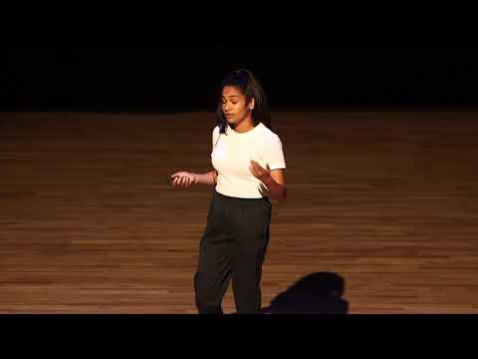
Ted Talk On The Effects Of Social Media On Relationships By Mayurakshi Ghosal
Source: https://www.youtube.com/watch?v=LYl4BdBabl4

source:https://www.google.com/search?q=nitv&rlz=1C1CHZL_enIN723IN723&sxsrf=AOaemvKdbZOsqRU9NSe0Dg3QF5yoAWPhCQ:1638317576545&source=lnms&tbm=isch&sa=X&ved=2ahUKEwi9hbfJqMH0AhUg7rsIHS2vCiYQ_AUoAXoECAEQAw&biw=1536&bih=754&dpr=1.25#imgrc=PnTFBQjeSIa6KM&imgdii=_Bn0m3c0F29p2M
https://www.google.com/search?q=Aboriginal+People%E2%80%99s+Television+Network+in+Canada&rlz=1C1CHZL_enIN723IN723&sxsrf=AOaemvKwXeHaY0j6d8ymqXPU7dACFhewjw:1638316890670&source=lnms&tbm=isch&sa=X&sqi=2&ved=2ahUKEwiNurCCpsH0AhU57rsIHRDpBtUQ_AUoAXoECAEQAw&biw=1536&bih=754&dpr=1.25#imgrc=SGfcZSljRhL6cM
https://www.google.com/search?q=maori+tv+in+new+zealand&tbm=isch&ved=2ahUKEwj6nZjhpsH0AhUKhaQKHUaQCL0Q2-cCegQIABAA&oq=maori+&gs_lcp=CgNpbWcQARgAMgcIIxDvAxAnMgUIABCABDIECAAQQzIFCAAQgAQyBAgAEEMyBQgAEIAEMgUIABCABDIECAAQQzIFCAAQgAQyBQgAEIAEUNICWNICYIkNaABwAHgAgAFSiAGCAZIBATKYAQCgAQGqAQtnd3Mtd2l6LWltZ8ABAQ&sclient=img&ei=IbymYbqJHoqKkgXGoKLoCw&bih=754&biw=1536&rlz=1C1CHZL_enIN723IN723#imgrc=K3nYkQdfbV-Y6M
https://www.google.com/search?q=taiwan+indigenous+television&rlz=1C1CHZL_enIN723IN723&hl=en&sxsrf=AOaemvJDfLkjOOmp1RsBCBNWv3ru_fvIOg:1638317187463&source=lnms&tbm=isch&sa=X&ved=2ahUKEwjgqfOPp8H0AhV8_rsIHRJ2DH0Q_AUoAXoECAEQAw&biw=1536&bih=754&dpr=1.25#imgrc=zrFHis4AwziFAM&imgdii=-NXohuAxNCrFSM

As an ethnographer, it is important to study this phenomenon and analyse how people perceive social media to dictate the status of their relationships. It is also noteworthy to consider the various opinions people have when introduced to new media, the multiplicity of media ideologies that people may have and if social media dating is capable of invoking any behavioural tendencies, whether the access to dating apps and variety of apps to communicate has sped up the process, do quick link-ups lead to quick break-ups, so on and so forth.
Undoubtedly, the choice to connect with strangers, become friends, and eventually start dating has become an easy affair. All you need is a smartphone, a stable internet connection, installing the required app and then clicking on friend requests, double-tapping for validation, and just swiping away. Surprisingly, one can now have multiple conversations not just with multiple people but also with the same person over different apps. The web is for real. Pun intended.
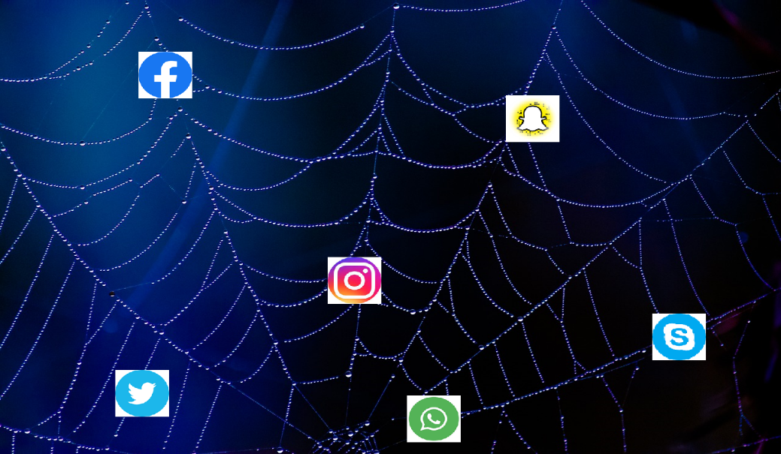
A Visual Representation Of The Web-like Usage Of Social Media
Source: Google Images

source:https://www.google.com/search?q=nitv&rlz=1C1CHZL_enIN723IN723&sxsrf=AOaemvKdbZOsqRU9NSe0Dg3QF5yoAWPhCQ:1638317576545&source=lnms&tbm=isch&sa=X&ved=2ahUKEwi9hbfJqMH0AhUg7rsIHS2vCiYQ_AUoAXoECAEQAw&biw=1536&bih=754&dpr=1.25#imgrc=PnTFBQjeSIa6KM&imgdii=_Bn0m3c0F29p2M
https://www.google.com/search?q=Aboriginal+People%E2%80%99s+Television+Network+in+Canada&rlz=1C1CHZL_enIN723IN723&sxsrf=AOaemvKwXeHaY0j6d8ymqXPU7dACFhewjw:1638316890670&source=lnms&tbm=isch&sa=X&sqi=2&ved=2ahUKEwiNurCCpsH0AhU57rsIHRDpBtUQ_AUoAXoECAEQAw&biw=1536&bih=754&dpr=1.25#imgrc=SGfcZSljRhL6cM
https://www.google.com/search?q=maori+tv+in+new+zealand&tbm=isch&ved=2ahUKEwj6nZjhpsH0AhUKhaQKHUaQCL0Q2-cCegQIABAA&oq=maori+&gs_lcp=CgNpbWcQARgAMgcIIxDvAxAnMgUIABCABDIECAAQQzIFCAAQgAQyBAgAEEMyBQgAEIAEMgUIABCABDIECAAQQzIFCAAQgAQyBQgAEIAEUNICWNICYIkNaABwAHgAgAFSiAGCAZIBATKYAQCgAQGqAQtnd3Mtd2l6LWltZ8ABAQ&sclient=img&ei=IbymYbqJHoqKkgXGoKLoCw&bih=754&biw=1536&rlz=1C1CHZL_enIN723IN723#imgrc=K3nYkQdfbV-Y6M
https://www.google.com/search?q=taiwan+indigenous+television&rlz=1C1CHZL_enIN723IN723&hl=en&sxsrf=AOaemvJDfLkjOOmp1RsBCBNWv3ru_fvIOg:1638317187463&source=lnms&tbm=isch&sa=X&ved=2ahUKEwjgqfOPp8H0AhV8_rsIHRJ2DH0Q_AUoAXoECAEQAw&biw=1536&bih=754&dpr=1.25#imgrc=zrFHis4AwziFAM&imgdii=-NXohuAxNCrFSM

According to the interviews conducted by Gershon, most people commented that disconnecting over social media was a big no-no. It was observed that people preferred an in-person conversation to end their relationship and seek closure. Breaking up over a text message, or changing their relationship status on Facebook was considered to be insensitive of the other’s feelings and was also seen as a sign of cowardice. To discuss it further, different schools of thought give rise to different media ideologies which in turn give rise to how different people speak for and against disconnecting over social media. It is similar to what Gershon notices, many students consider an email to be formal due to its need to have greetings and salutations, whereas the same email is considered to be informal by Gershon herself as it does away with the hassles of writing it in a legible script and posting it so as to be received in time.

A Scene From The Web-series FRIENDS Where A 17 Page (Front and Back) Letter Leads To Miscommunication Between The Reel Couple.
Source: Google Images

source:https://www.google.com/search?q=nitv&rlz=1C1CHZL_enIN723IN723&sxsrf=AOaemvKdbZOsqRU9NSe0Dg3QF5yoAWPhCQ:1638317576545&source=lnms&tbm=isch&sa=X&ved=2ahUKEwi9hbfJqMH0AhUg7rsIHS2vCiYQ_AUoAXoECAEQAw&biw=1536&bih=754&dpr=1.25#imgrc=PnTFBQjeSIa6KM&imgdii=_Bn0m3c0F29p2M
https://www.google.com/search?q=Aboriginal+People%E2%80%99s+Television+Network+in+Canada&rlz=1C1CHZL_enIN723IN723&sxsrf=AOaemvKwXeHaY0j6d8ymqXPU7dACFhewjw:1638316890670&source=lnms&tbm=isch&sa=X&sqi=2&ved=2ahUKEwiNurCCpsH0AhU57rsIHRDpBtUQ_AUoAXoECAEQAw&biw=1536&bih=754&dpr=1.25#imgrc=SGfcZSljRhL6cM
https://www.google.com/search?q=maori+tv+in+new+zealand&tbm=isch&ved=2ahUKEwj6nZjhpsH0AhUKhaQKHUaQCL0Q2-cCegQIABAA&oq=maori+&gs_lcp=CgNpbWcQARgAMgcIIxDvAxAnMgUIABCABDIECAAQQzIFCAAQgAQyBAgAEEMyBQgAEIAEMgUIABCABDIECAAQQzIFCAAQgAQyBQgAEIAEUNICWNICYIkNaABwAHgAgAFSiAGCAZIBATKYAQCgAQGqAQtnd3Mtd2l6LWltZ8ABAQ&sclient=img&ei=IbymYbqJHoqKkgXGoKLoCw&bih=754&biw=1536&rlz=1C1CHZL_enIN723IN723#imgrc=K3nYkQdfbV-Y6M
https://www.google.com/search?q=taiwan+indigenous+television&rlz=1C1CHZL_enIN723IN723&hl=en&sxsrf=AOaemvJDfLkjOOmp1RsBCBNWv3ru_fvIOg:1638317187463&source=lnms&tbm=isch&sa=X&ved=2ahUKEwjgqfOPp8H0AhV8_rsIHRJ2DH0Q_AUoAXoECAEQAw&biw=1536&bih=754&dpr=1.25#imgrc=zrFHis4AwziFAM&imgdii=-NXohuAxNCrFSM

No matter how many times the advantages of using social media are advocated, it will always create a difference in perception and comprehension. A text message may lead to miscommunication and the scope of literally reading between the lines of texts is heightened, whereas a vis-à-vis is more direct and is accompanied by body language, and hand and facial gestures for better comprehension. The text message may give someone the power to express exactly what they mean, which might be difficult to say in person, as one can manipulate the time when the message is being sent, the tone of the words, the emoticons being sent in order to gain control over the flow of communication, whereas a face-to-face conversation may seem like a forceful, stressful confession which many like to avoid.
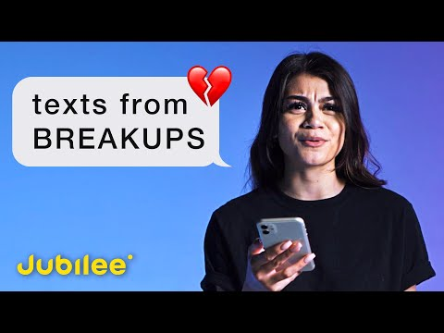
An Insightful Video on How People Break-up Over Texts And How It Has Affected Them
Source: https://www.youtube.com/watch?v=TrbtTJY885k

source:https://www.google.com/search?q=nitv&rlz=1C1CHZL_enIN723IN723&sxsrf=AOaemvKdbZOsqRU9NSe0Dg3QF5yoAWPhCQ:1638317576545&source=lnms&tbm=isch&sa=X&ved=2ahUKEwi9hbfJqMH0AhUg7rsIHS2vCiYQ_AUoAXoECAEQAw&biw=1536&bih=754&dpr=1.25#imgrc=PnTFBQjeSIa6KM&imgdii=_Bn0m3c0F29p2M
https://www.google.com/search?q=Aboriginal+People%E2%80%99s+Television+Network+in+Canada&rlz=1C1CHZL_enIN723IN723&sxsrf=AOaemvKwXeHaY0j6d8ymqXPU7dACFhewjw:1638316890670&source=lnms&tbm=isch&sa=X&sqi=2&ved=2ahUKEwiNurCCpsH0AhU57rsIHRDpBtUQ_AUoAXoECAEQAw&biw=1536&bih=754&dpr=1.25#imgrc=SGfcZSljRhL6cM
https://www.google.com/search?q=maori+tv+in+new+zealand&tbm=isch&ved=2ahUKEwj6nZjhpsH0AhUKhaQKHUaQCL0Q2-cCegQIABAA&oq=maori+&gs_lcp=CgNpbWcQARgAMgcIIxDvAxAnMgUIABCABDIECAAQQzIFCAAQgAQyBAgAEEMyBQgAEIAEMgUIABCABDIECAAQQzIFCAAQgAQyBQgAEIAEUNICWNICYIkNaABwAHgAgAFSiAGCAZIBATKYAQCgAQGqAQtnd3Mtd2l6LWltZ8ABAQ&sclient=img&ei=IbymYbqJHoqKkgXGoKLoCw&bih=754&biw=1536&rlz=1C1CHZL_enIN723IN723#imgrc=K3nYkQdfbV-Y6M
https://www.google.com/search?q=taiwan+indigenous+television&rlz=1C1CHZL_enIN723IN723&hl=en&sxsrf=AOaemvJDfLkjOOmp1RsBCBNWv3ru_fvIOg:1638317187463&source=lnms&tbm=isch&sa=X&ved=2ahUKEwjgqfOPp8H0AhV8_rsIHRJ2DH0Q_AUoAXoECAEQAw&biw=1536&bih=754&dpr=1.25#imgrc=zrFHis4AwziFAM&imgdii=-NXohuAxNCrFSM

In addition, the power dynamic of a relationship may be affected by PDA on social media. The likes and dislikes of followers may boost or hedge the relationship, the photos and memories and their deletion after a breakup may cause mental stress. People find ways to disconnect over social media and may show behavioural tendencies like ghosting or benching. A public breakup may seem like a competition to some, where they feel the necessity to tell the world about the breakup. People may also opt to go live and stream their experience of a breakup where they feel that they are answerable to the world. In spite of the fact that social media relationships may seem like a detached affair, their impact may be emotionally overwhelming.
In a nutshell, adapting to new media takes time, the updates and the facilities an app may provide help in reducing the virtual distance and enabling a real-time experience. Anything that is new may face flak or praise and these opinions may change over time. Nonetheless, people eventually loosen up to new changes and that is how the wheel of life keeps on turning.

BIBLIOGRAPHY:
Gershon, Ilana. The Breakup 2.0: Disconnecting over New Media. 1st ed., Cornell University Press, 2012.
“Digital Heartbreak.” gradPSYCHMagazine, Apr. 2014, www.apa.org/gradpsych/2014/04/digital-heartbreak.
“The Effects of Social Media on Relationships | Mayurakshi Ghosal | TEDxYouth@DAA.” YouTube, uploaded by TEDx Talks, 29 Jan. 2019, www.youtube.com/watch?v=LYl4BdBabl4.
“People Read Their Last Breakup Texts.” YouTube, uploaded by Jubilee, 14 Mar. 2020, www.youtube.com/watch?v=TrbtTJY885k.

GOOGLE IMAGES:
•https://www.reddit.com/r/dataisbeautiful/comments/tdhu0/peak_breakup_times_throughout_the_year_as/
•https://pixabay.com/photos/spider-web-blue-dew-drops-2990108/
•https://edtechsandyk.blogspot.com/2017/02/we-were-on-break.html

Detached and emotional

