


BILDBEREICH

WASTE ABC
Waste disposal at the University of Tübingen

Updated: February 2024

Division VIII – Construction, Safety and Environment
Environmental Protection and Energy Management


This Waste ABC contains information on how to dispose of waste within the University. Please note, that there is a legally binding waste hierarchy according to which waste is to be: prepared for reuse, recycled, recovered or, if this is not possible for technical or economic reasons, disposed of. Even before waste is produced, alternatives should be considered and purchases checked for sustainability.

This booklet describes various disposal methods for household-type waste in non-clinical areas of the University.

The disposal of special chemical waste is dealt with elsewhere. The allocation of responsibilities is set out on page 5.

Why do we separate waste before collecting it?

- because this is essential for recycling recyclable materials; it contributes to the conservation of resources and helps protect the environment (however, prevention should always come first!)

- because the law governing recycling and the municipal waste statutes mandate separate collection

- because separate collection saves us considerable disposal costs

What are the quantities involved?

The following figures give you an idea of the amount of waste collected separately at the University in 2022; such quantities are definitely worth recycling:

Paper: ca. 323 t

Polystyrene (Morgenstelle): ca. 85 m³

Soil ca. 22 t
Metals ca. 9 t
Plastic film ca. 22 m³

Although this waste is recyclable, waste avoidance should be the top priority!
What does disposal cost?

The disposal costs for waste (excluding hazardous waste) are currently around € 300,000 per year.
Residual waste accounts for the largest share of this. Consistent garbage separation could reduce costs by up to 2/3.
You have already paid for the disposal of packaging when you make your purchase. If this waste ends up in the residual garbage instead of the recycling waste, its disposal is paid for twice over.
As of June 1, 2012, along with packaging, other recyclable items made of plastic and metal are to be collected separately. Paper/cardboard and glass still go, respectively, in the paper collection or in the used-glass bin.

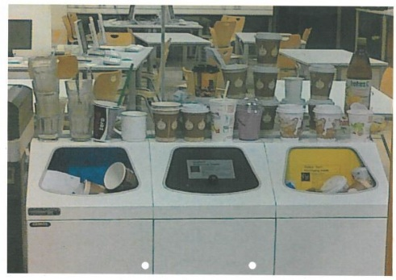
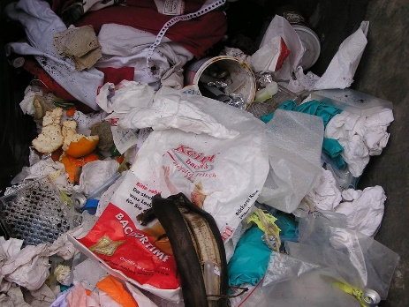
Unsorted residual waste

Litter in the Library
Recycling Yard:

For University institutions there is a recycling yard at the Morgenstelle Campus near the district heating plant II.

It is a collection point for various categories of waste, i.e. in addition to containers for glass, metal, paper, etc., there is a room for collecting electronic waste, batteries, CDs, etc. It is also possible to pick out parts that are still usable.

The recycling yard is open two hours a day: Mon., Tues., Thurs., and Fri. from 9:30 to 11:30 am, Wed. from 1:00 to 3:00 pm.
The recycling center may be reached by telephone during opening hours on phone no. 77759.

Private waste will not be accepted!
No deliveries outside opening hours!

Waste ABC structure:

The requirements for waste disposal are subject to constant change, so the information presented here on the various disposal methods is not the final word.

The main section begins with a brief overview of the disposal methods for household-type commercial waste at the University. All waste marked with * is then described in more detail in alphabetical order in the appendix.

At the end, collection containers are shown which are used by most University facilities and which are available from the central Purchasing Office.

Definition of responsibilities, contact persons, information

Waste management officer – University
Annette Eissler 77421

Waste disposal advisor Anita Jenewein 77753

Waste management officers – Hospitals
Marco Stengel 80097
Lucia Haug 87530

Hazardous waste management officer – University
Dr. Jens Weber 77386

Vehicle pool – University
Petra Bartmann 74211

Disposal of used fixing and developing baths

Photochemicals – University
Dr. Jens Weber 77386

Animal carcass disposal

Animal welfare institution, veterinary service 80125

and laboratory animal science

Radioactive waste

Dr. Georg Fehrenbacher 74185

Chemicals exchange

Director: Dr. Jens Weber 77386
Hand in/pick up: Björn Niederhöfer 77892

Collection points

Auf der Morgenstelle: Recycling Yard, near district heating plant II
Opening hours: Mon., Tues., Thurs., Fri.: 09:30 – 11:30 am
Wednesday: 1:00 – 3:00 pm
Wilfried Riehle: 77759

Accepts household-type waste that accumulates at University facilities, as well as batteries, precious metals, cork, CDs, cell phones, expired breathing filters, etc.

Town/valley campus: Environment Protection and Energy Management
Hölderlinstr.11
Annette Eissler 77421
Anita Jenewein 77753

Accepts batteries, CDs, cell phones, polystyrene, film, cork, aluminum, used or expired breathing filters.

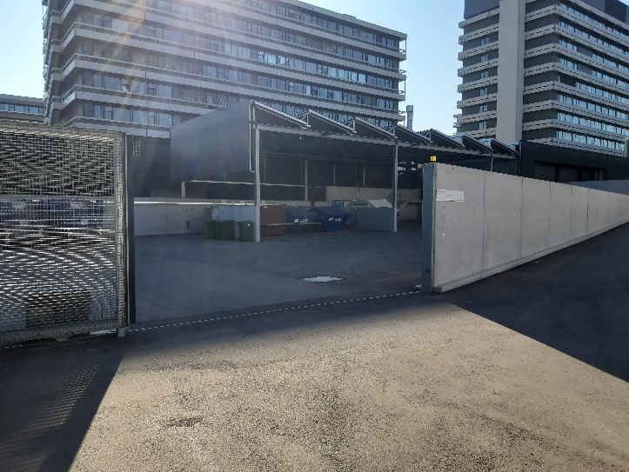

Recycling yard Morgenstelle science campus (Photo: Wilfried Riehle)

Aluminum* |  | Production is highly water-polluting and energy-intensive ⇒ 10 times as high as for the production of tinplate and 27 times as high as for the production of glass ⇒ this highly environmentally unfriendly material should be avoided wherever possible  Since the Recycling Yard at the University accepts aluminum, we recommend separate collection. | − Recycling waste (yellow bag)*  (press small pieces of aluminum together to form a larger ball)  − Large pieces/amounts Recycling Yard
Batteries*  Lithium batteries  defective or  >500g  see battery disposal information sheet |  | Batteries containing heavy metals poison the environment and must therefore not be disposed of in the general waste; they must be collected separately.  ⇒ The use of mains adapters, rechargeable batteries or solar-powered devices is recommended as an alternative  Li batteries: Poles must be taped, preferably disposed of in the original packaging. FIRE HAZARD! | − Register for collection service  − Recycling Yard  Morgenstelle Campus  (See information sheet “Waste information on battery disposal”)  Make appointment and deliver to Recycling Yard, phone 77759
Bottle caps (from single-use bottles) |  | Disposable bottles should be put in the used glass collection without caps/lids. | Recycling waste (yellow bag)*
Bottles, single-use |  | Non-standard colored glass (e.g. blue, red) goes in the green glass bin. Where possible, preference should be given to returnable glass bottles | − Glass bins  − Recycling waste (yellow bag)* for plastic bottles
Breathing filters  (expired) |  |  | − Register for collection service  − Recycling Yard.  Morgenstelle Campus
Cannulas |  | Never dispose of needles in residual waste or the recycling/yellow bag - Risk of injury! | Puncture-proof collection containers  (Hazardous waste disposal, Dr. Jens Weber 77386)
Cans (metal) |  | Press cans together at the top (this prevents them from filling up with other waste before they are sorted out by the metal separator) | Recycling waste (yellow bag)*
Cans, tin,  tin canisters  (not contaminated) |  | Before cans are placed in the recycling bag/bin, they should be pressed together at the top so that no foreign matter can get in. | − Recycling waste (yellow bag)*  − Scrap metal bins  (Recycling Yard)
Carbon paper |  |  | Residual waste
Carboard boxes   |  | Where necessary: Collect waste paper in them, otherwise, when empty fold them flat!  For smaller quantities, ask the waste advice service (77421, 77753) about disposal options on site. | − Town/valley c.: Register for collection  − Morgenstelle C.:  Recycling Yard
Catalogues |  | If you do not wish to receive them, inform the sender/ unsubscribe  Do not put more than one catalog at a time into the paper collection, otherwise the paper bags will be too heavy. | − Town/valley c.: Register a delivery  − Morgenstelle Campus:  Recycling Yard
CDs * |  | CDs are made chiefly of polycarbonate and are a high-quality recycling product. | Recycling Yard
Ceramics |  | Not to be thrown in the glass bin!  Dispose of them in the laboratory glass bin at the Recycling Yard. | − Register for collection service  − Recycling Yard  Morgenstelle C.  −Residual waste
Coffee filters |  |  | Organic waste
Computers* |  | Spare parts available at the Recycling Yard | − Town/valley c.: Register for collection service  − Morgenstelle Campus: Recycling Yard
Culture dishes |  |  | Materials contaminated by chemicals
Cups, disposable |  | Disposable cups increase waste as they are not recyclable  Reusable cups such as KeepCups or deposit cups such as ReCup are a good alternative (see www.besser-bechern.de) | Recycling waste (yellow bag)*
Data privacy papers |  | Papers with data protection-relevant content (e.g. name, address, date of birth, marital status, personnel number, pay grade, appraisals, certificates). Report larger quantities to the waste advisory service. | − Recycling Yard  − Shredders at the Neue Aula  77706, 72523
Electronic waste* |  | Spare parts available at the Recycling Yard | − Town/valley c.:  Register for collection service  − Morgenstelle C.: Recycling Yard
Energy-efficient light bulbs |  | Please call to arrange a time for delivery.  Energy-saving light bulbs contain mercury – so do not break them and do not dispose of them in the residual waste! | − Town/valley c.:  Neue Aula  77706/72523  − Morgenstelle C.: TBA Facilities Management  Electric. workshop  74043
Eppendorf tubes |  |  | Materials contaminated by chemicals
Flowers and plant waste |  |  | Organic waste, recycling center if necessary
Fluorescent tubes |  | Please call to arrange a time for delivery.  Fluorescent tubes contain mercury – so do not break them and do not dispose of them in the residual waste! | − Town/valley c.:  Neue Aula  77706/72523  − Morgenstelle C.: TBA Facilities Management  Electric. workshop  74043  Recycling Yard
 | Food waste |  | Organic waste
Furniture |  | Disassemble and sort (wood to wood waste, metal to scrap waste)  Usable furniture: ask the waste disposal office for current status | − Town/valley campus:  Register for collection service  − Morgenstelle C.: Recycling Yard
Glass*  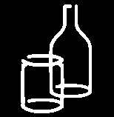 |  | If possible, use returnable glass.  Unusually colored glass (e.g. blue, red) goes in the green glass bin.  Only regular glass (no laboratory glass or flat glass) goes in the glass bins! | − Return reusable bottles to the store  − Glass bins  − Laboratory glass to Recycling Yard
Glass, flat |  | Do not put flat glass in the bins for normal glass. For larger quantities, please contact the University's waste advisory service. | See: laboratory glass
Glass, wired |  |  | See: flat glass
Gloves, disposable |  | Not to be thrown in the recycling (yellow bag) | Residual waste
Hand towels, disposable |  | Small quantities go in the organic waste | Residual waste
Ink jet cartridges* |  | See waste information on proper disposal of toner cartridges | Recycling Yard
Laboratory glass*  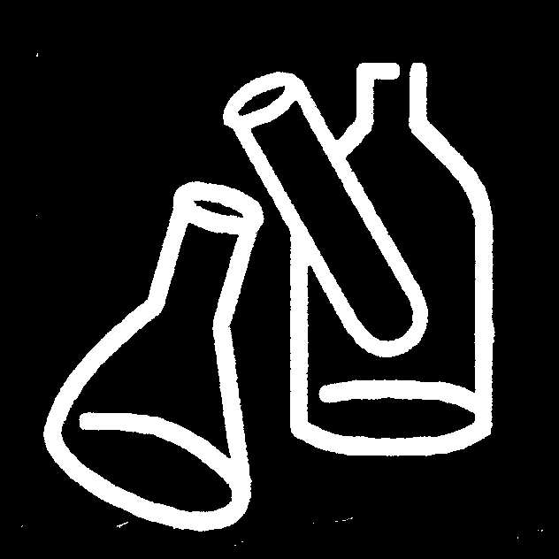 |  | Laboratory glass has a higher melting point than regular glass, so it must not be disposed of in the normal glass bin  Laboratory glassware must be free of chemical or biological contamination - otherwise dispose of as hazardous waste! | − Town/valley campus:  Register for collection service  − Morgenstelle C.:  Recycling Yard  (Laboratory glass  bins)
Lids from single-use bottles, jars, etc. |  | Before bottles are disposed of with the waste glass, the lids should be removed! | Recycling waste (yellow bag)*
Magazines |  | Unsubscribe from unwanted or multiple magazine mailings | − Town/valley campus:  Register for collection service  − Morgenstelle C.:  Recycling Yard
Magnetic tapes |  | Observe data privacy law. For large quantities, contact the University's waste advisory service | Residual waste
Overhead projector transparencies |  | Transparent films are collected separately where possible, e.g. in the Uni warehouse, hazardous waste warehouse | − Morgenstelle C.:  Recycling Yard  Otherwise, residual waste
 | Packaging materials | Glass and paper packaging should be taken to the relevant collection points! | Recycling waste (yellow bag)*
Paper*  (See also recycled paper) |  | Use paper sparingly, print and copy double-sided. Use recycled paper. In contrast to recycled paper production, the production of virgin fiber paper uses up valuable forests, is energy-intensive and pollutes water and the atmosphere | − Town/valley campus:  Register for collection service  − Morgenstelle C.:  Recycling Yard  Observe data privacy*, (possibly shredding beforehand)
Paper, coated or soiled |  |  | Residual waste
Paper recycling* |  | Use recycled paper. The production of paper from virgin fibers leads to the deforestation of primeval forests, the pollution of lakes and rivers, and consumes a lot of energy. Paper must be used in moderation ⇒ e.g. print and copy on both sides, reduce printouts to what is strictly necessary | − Register for collection service  − Recycling Yard  Morgenstelle C.  Observe data privacy*, if possible first put through shredder
Paper towels |  | Paper towels are compostable in small quantities and absorb moisture in organic waste. | Residual waste  Organic waste
Petri dishes |  |  | Materials contaminated by chemicals
Pipette tips |  |  | Materials contaminated by chemicals
Plastic canisters  (empty and cleaned of harmful residues) |  | Any filling materials containing hazardous substances must be disposed of via hazardous waste disposal (Dr. Jens Weber 77386) | Recycling waste (yellow bag)*
Plastic  (general)* |  |  | Recycling waste (yellow bag)*
Plastic films |  | Transparent films are collected separately where possible, e.g. in the University warehouse, hazardous waste warehouse | − Register for collection service  − Recycling Yard  Morgenstelle C.  Otherwise, recycling waste (yellow bag)*
Plastic pipes/hoses |  |  | Materials contaminated by chemicals
Polystyrene* |  | Clean polystyrene without stickers is collected at the recycling yard for recycling | If possible, return it to the distributor  − Recycling waste (yellow bag)*  − Recycling Yard
Paint buckets |  | Without liquid contents, dry | − Recycling waste (yellow bag)*  residual waste
Polystyrene beads* |  |  | Recycling Yard  Recycling waste (yellow bag)
Printers |  | Spare parts available at the Recycling Yard | − Town/valley c.: Register for collection service  − Morgenstelle C.:  Recycling Yard
Projector lamps |  | Please call to arrange a time for delivery. DO NOT send by internal post.  Energy-saving light bulbs contain mercury – so do not break them and do not dispose of them in the residual waste! | − Town/valley campus:  Neue Aula  77706/72523  − Morgenstelle C.: TBA Facilities Management  Electrical workshop  74043
Rechargeable batteries  Li batteries, defective or  >500g see battery disposal information sheet |  | Rechargeable batteries may be recharged up to 1000 times ⇒ Reduction of waste. The high metal content makes recycling worthwhile.  Lithium batteries: Poles must be taped, preferably disposed of in the original packaging. FIRE HAZARD! | Recycling Yard  Morgenstelle Campus  Make an appointment and deliver to  Recycling Yard  Phone 77759
Refrigerators and freezers* |  | Replace old energy-guzzling appliances with new, efficient appliances. There may be a subsidy available  Energy management 73557 | − Town/valley campus:  Register for collection service  − Morgenstelle C.:  Recycling Yard
Scrap metal |  |  | Register for collection service  − Morgenstelle C.:  Recycling Yard
Tea bags |  |  | Organic waste
Toner cartridges* |  | See waste information on proper disposal of toner cartridges | Recycling Yard
Transparent plastic film |  | Transparent plastic film is collected separately where practicable, e.g. in the University warehouse, hazardous waste warehouse. | − Register for collection service  − Recycling Yard  Morgenstelle C.  Otherwise, recycling waste (yellow bag)*
Transport packaging |  | See information on packaging* in general | − Return to distributor or dealer  − Recycling waste (yellow bag)*
 | Videotapes,  video cassettes | Ensure compliance with data protection! | Residual waste
 | Wood waste* | Dismantle wooden objects as far as possible.  Register treated wood with Mr. Riehle (77759). | − Town/valley campus: To  Register for collection service  − Morgenstelle C.:  Recycling Yard
 | Writing instruments | Use refillable products wherever possible | Residual waste

Reproduced with permission of ©TOM

Aluminum

Aluminum is an extremely water-polluting and energy-consuming material. Producing a ton of aluminum uses 4 times as much energy as the production of a ton of paper, 10 times more than for a ton of tinplate and 27 times more than a ton of glass.

If you compare recycled and newly produced aluminum in terms of energy consumption, water and air pollution during production, the energy consumption for melting down aluminum is only 5-10% of the energy consumption for new production. Recycling therefore makes perfect sense, especially as aluminum is usually produced in pure form.

Prevention should still be the top priority!

ENVIRONMENTAL TIPS:

- Avoid using aluminum wherever possible
- Aluminum should not be used at all for packaging, as other packaging materials (e.g. sandwich paper) are available that are less harmful to the environment

WHERE TO DISPOSE OF IT?
Aluminum foil, lids and trays go in the yellow bag/bin recycling. Compress small quantities into larger bundles, as small fragments fall through a grid when the recyclable waste is sorted; they end up in the residual waste.

Aluminum may be handed in at the Recycling Yard at Morgenstelle Campus - the University benefits from the payment here.

Batteries and accumulators

Batteries may contain heavy metals such as lead, cadmium or mercury. After use, these substances may be released into the environment via waste incineration. Heavy metals accumulate in plants, animals and in the human organism and can lead to serious health problems. Used batteries must therefore be collected separately. They must not be disposed of along with residual waste.

Accumulators are rechargeable batteries and sensible alternatives to batteries, as they can be recharged around 1000 times with optimum charge/discharge cycles and therefore significantly reduce the volume of waste. Recycling rechargeable batteries is very worthwhile, especially because of their high metal content.

Li batteries and rechargeable batteries must be in original packaging or with taped contacts and handed in for battery collection. Defective or ≥ 500g must be taken to the Recycling Yard by prior arrangement – FIRE HAZARD!

ENVIRONMENTAL TIPS:

- If possible, do not use batteries, but power supply units or rechargeable batteries.
- Use solar-powered devices (e.g. calculators) if possible.

WHERE TO DISPOSE OF THEM?
Batteries and accumulators may be handed in at the Recycling Yard at Morgenstelle Campus or sent there by internal mail or be picked up: Opening hours:
Mon., Tues., Thurs., Fri.: 9:30-11:30 am
Wed: 1:00-3:00 pm
More detailed information may be found in the following information on battery disposal.

W a s t e - i n f o

Battery disposal

Under German law, all used batteries must be taken back free of charge under a system known as GRS (Gemeinsames Rücknahmesystem Batterien). GRS organizes the take-back of portable batteries in accordance with the law – regardless of system, brand or origin.

All used batteries and rechargeable batteries, whether they contain harmful substances, are low-pollutant or button cells, can be collected in a container and then taken to the existing collection points.

The terminals of lithium batteries/rechargeable batteries must be taped and they may only be placed singly in battery collection containers (≤10%).

Li batteries and rechargeable batteries that are damaged or >500g must be taken to the recycling center by prior arrangement due to the risk of fire.

Batteries and rechargeable batteries may be handed in at the following collection point at the University or sent there by internal mail or be picked up:

Recycling Yard at district heating plant II

Recycling Yard opening hours: Mon., Tues., Thurs., Fri.: 9:30 - 11:30 am
Wed: 1:00 - 3:00 pm

Empty starter batteries (for field measurements) originally purchased from the central warehouse may also be returned there.

Cartridges: Toner cartridges, ink cartridges

A cartridge is an expensive and technically complex product, consisting of a robust plastic housing filled with rollers, gears, a counter and a relatively small amount of toner.

Empty cartridges do not go in the residual waste, nor in the recycling waste!!!

It is possible and economical to recycle these cartridges and thus reuse them several times.
Cartridges may be handed in at the following collection point at the University of Tübingen (also by internal mail):

WHERE TO DISPOSE OF THEM?

Recycling Yard at district heating plant II

Opening hours:
Mon., Tues., Thurs., Fri.: 9:30 - 11:30 am
Wed: 1:00 - 3:00 pm

Detailed information on the disposal of Kyocera and Morgenstern products may be found in the following information on waste disposal and on the Purchasing office website (Div. VII/3).

ENVIRONMENTAL TIPS:

- Only return completely empty cartridges for recycling or refilling. To avoid damaging the cartridges, they should be returned in their original packaging.
- Do not make unnecessary printouts or copies.
- Use refillable cartridges.

Important note for internet-connected devices:
In future, the replacement of toner and waste toner containers for all devices connected to the internet will be automated by Morgenstern company employees. An explicit request for materials is therefore no longer necessary for these devices.

Kyocera toner return for offline devices
The manufacturer Kyocera takes back Kyocera toner cartridges and waste toner containers from Morgenstern rental devices.
Collection boxes for Kyocera materials may be requested free of charge from Kyocera.
Link to Kyocera registration form: https://kyocera.takeback.eu/auth/login

The full collection boxes are then collected by Kyocera -> see next page for procedure.

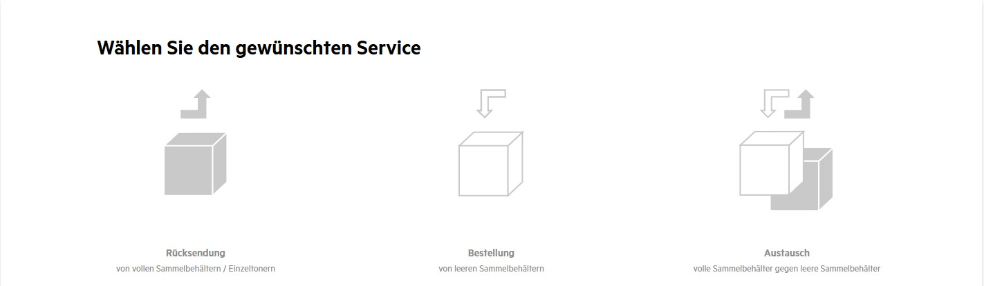

Select service: return, order, exchange

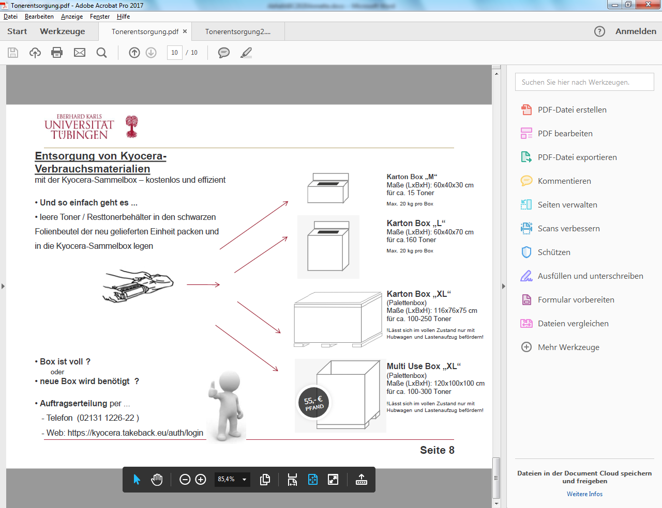

Disposing of Kyocera cartridges with a Kyocera-collection box: free and efficient

- Pack the empty/ nearly empty toner container into the black plastic bag in which the new unit was delivered, then put it into the Kyocera collection box. If the box is full, or a new one is needed, order a new one by phone or via the company website:
- Phone (021311226-22)
- Web: https://kyocera.takeback.eu/auth/login

Box M measuring: 60x40x30 cm for approx. 15 toner cartridges. Max. 20 kg per box
Box L Measuring: 60x40x70 cm for approx.160 toner cartridges. Max. 20 kg per box
XL boxes cannot be lifted without mechanical aid.

W a s t e - i n f o

to proper disposal of toner cartridges

- All empty inkjet cartridges (offline devices):
To the Recycling Yard for refilling.

- All remaining empty toner cartridges (offline devices):
To the Recycling Yard for refilling.

WHERE TO DISPOSE OF IT?

Recycling center at district heating plant II
Recycling Yard opening hours:
Mon., Tues., Thurs., Fri.: 9:30 - 11:30 am
Wed: 1:00 - 3:00 pm

If delivery is not possible, send by internal mail.

Please return empty toner cartridges in their original packaging!

There is a good recycling system for toner cartridges – they do not go in the residual waste!
W a s t e - i n f o
CD disposal

A CD consists mainly of polycarbonate. The pressed plastic disc is coated with a layer of aluminum and painted and printed with a protective layer. During recycling, the composite is separated using either mechanical or chemical processes. This allows a high-quality plastic to be recovered.

The CDs are collected centrally at the University of Tübingen and forwarded for recycling.

CDs can be handed in at the following collection point at the University of Tübingen or sent by internal mail:

Recycling center at district heating plant II

Recycling Yard opening hours: Mon., Tues., Thurs., Fri.: 9:30 - 11:30 am
Wed: 1:00 - 3:00 pm

Please take care to ensure data privacy! If a CD contains confidential data, make a deep, wide scratch in the surface with a sharp object.

Computers

Computers, cell phones and the like, cause around 33 million tons of the greenhouse gas carbon dioxide (CO2) to be released every year, which is more than all of German air traffic. In Germany alone, 25 coal-fired power plants would be needed to cover the electricity requirements of information technology.

ENVIRONMENTAL TIPS:

When making new purchases, pay attention to the energy consumption of appliances. Use a plug board that can be switched off (available from Purchasing) to prevent power consumption when appliances are powered down.

You can get spare parts at the Recycling Yard.

WHERE TO DISPOSE OF THEM?

Recycling Yard at Morgenstelle Campus 77759
at district heating plant II
Recycling Yard opening hours: Mon., Tues., Thurs., Fri.: 9:30 - 11:30 am
Wed: 1:00 - 3:00 pm

Defunct computers in the town/valley area may be registered for collection.

Electronic waste

Electrical appliances contain high-quality raw materials (e.g. precious metals) that are worth recovering. Some components contain environmentally hazardous substances that must be disposed of separately. For this reason, electrical appliances must not be disposed of with the residual waste.

ENVIRONMENTAL TIPS:

- When making new purchases, pay attention to low energy consumption, durability, retrofit guarantees and reparability.

- When purchasing a new appliance, it is advisable to ask the retailer whether they will take back the old appliance. This should be contractually agreed at the time of purchase.

- Spare parts available from the Recycling Yard.

WHERE TO DISPOSE OF IT?

Electronic waste may be delivered to the Recycling Yard. In the town/valley area, it may be collected on request and taken for proper disposal.

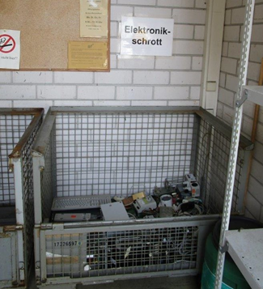

Cage for the collection of electronic waste at the
Recycling Yard

Glass

Used glass and reusable bottles must not end up in the waste bins. Cleaning staff have been instructed not to empty incorrectly filled paper containers in the workplace.

There are reverse-vending machines in buildings where drinks machines sell returnable bottles.
Where the use of disposable glass is unavoidable, it is disposed of in glass bins.

Glass bins are currently in place:
- At the Recycling Yard (there is also a bin for laboratory glass)
- Behind the Morgenstelle campus canteen (Mensa)
- At the Lothar-Meyer Building (Wilhelmstr. 56)
- https://www.abfall-kreis-tuebingen.de/entsorgen/wohin-mit-den-abfaellen/container-standorte/altglascontainer-stadt-tuebingen/

Glas is collected separately according to:
- Hollow glass
Separated according to the colors white, brown and green. Other colored glass is assigned to green glass.
Lids must be removed (they go in the yellow bag recycling).

- Laboratory glass, other glass types
Flat glass and high-melting point laboratory glass must not be disposed of in the regular glass collection. There is a separate bin for disposing of clean laboratory glass at the Recycling Yard. If it cannot be cleaned before disposal, the laboratory glass can be disposed of as hazardous waste via the hazardous waste collection point in the Chemicals Store. Laboratory glassware from the town/valley area may be picked up on request and taken to the Morgenstelle Campus.

The following also go into the laboratory glass bin:
Ceramics, window glass, wired glass and other flat glass

Lightbulbs go in the residual waste, fluorescent tubes, LEDs and energy-saving lamps must be disposed of separately (see keyword “Lamps, globes, fluorescent tubes” in the ABC)

No other types of glass (e.g. laboratory glass, unusual colors (they go with the green glass), light bulbs, flat glass, etc.) may be placed in the regular glass bins!!!!!

ENVIRONMENTAL TIPS:

Multiple use, e.g. of reusable bottles, makes more sense than recycling. When shopping, preference should be given to regional products so as to minimize transport.

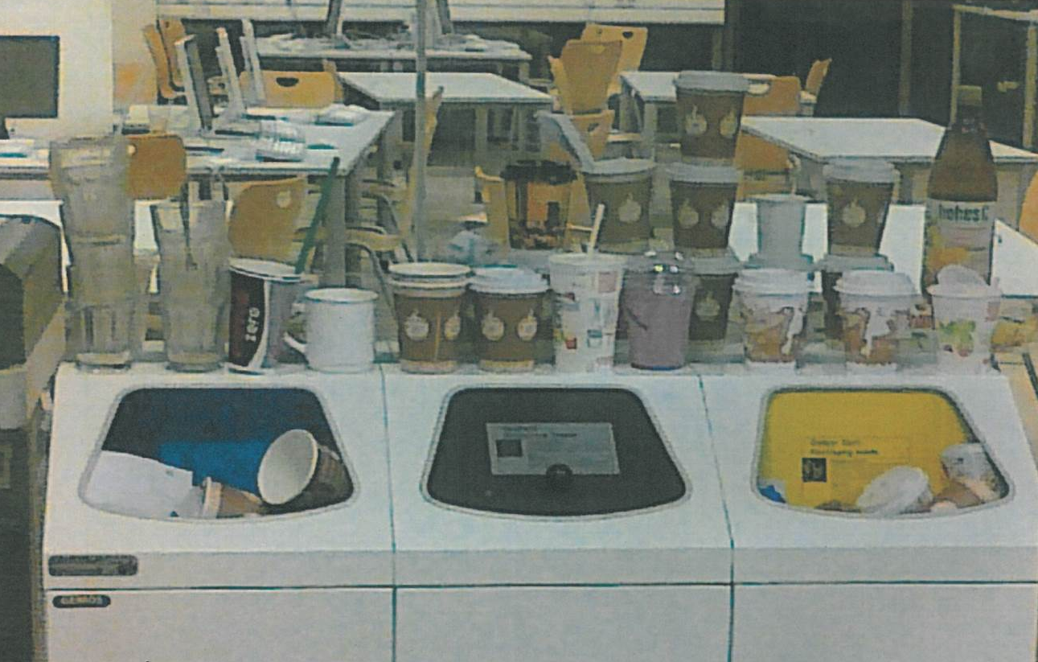
The “natural” end of single-use packaging! (Here in the Library)

Lamps, globes, fluorescent tubes

Fluorescent tubes and discharge lamps contain an average of around 20 mg of mercury. Due to the mercury content, fluorescent lamps and energy-saving lamps of all types are not without problems. Under no circumstances should the tubes be smashed for disposal, as even small amounts of mercury are very hazardous. These lamps must not be disposed of in the residual waste bin. The tube breaks during disposal and the mercury is released into the environment.

The components of the above lamps can be almost completely separated – using suitable processes – and recycled.

Fluorescent tubes, mercury vapor lamps, sodium vapor lamps and other discharge lamps as well as LEDs must therefore be collected separately.

WHERE TO DISPOSE OF THEM?

Recycling Yard, Morgenstelle campus

There are also two collection points operated by electricians from Facilities Management:
Morgenstelle C-Building: Electrical Workshop TBA, 74043
Neue Aula: HDLZ, 77706, 72523

If required, transportation to the collection point may be arranged via the collection service. An appointment may be arranged by calling 74211
In cases of direct delivery, the relevant collection point must be informed ahead of time.

Disused light fittings must not be broken under any circumstances!

ENVIRONMENTAL TIPS:

Use LEDs whenever possible.

Polystyrene (and polystyrene beads)

Styropor is the registered trademark of BASF AG for expandable polystyrene (EPS). The starting material is the monomer styrene. This is suspected of being carcinogenic.
Foam blowing agents are added in the production of polystyrene.

Although clean, unmixed polystyrene can be returned to the production cycle an infinite number of times, polystyrene causes problems in terms of its environmental impact during production, use and disposal.
Although polystyrene is easily recyclable, it is not always profitable to recycle it due to an oversupply. Polystyrene that is suitable for recycling must not have any impurities or adhesions (stickers, labels, etc.).

ENVIRONMENTAL TIPS:

- Use reusable packaging

- If it is not possible to use reusable packaging, ask suppliers for more environmentally-friendly alternatives such as wood wool, cellulose chips or waste paper/cardboard.

- Re-use polystyrene (beads)

WHERE TO DISPOSE OF THEM?

Collect clean polystyrene in bags and take it to the Recycling Yard or have it collected.
Soiled polystyrene or polystyrene chips go in the residual waste.
Polystyrene chips are hard to distinguish from cellulose chips, etc., so separate collection is impossible; therefore, they cannot be recycled. Polystyrene may also be disposed of in the yellow recycling bins/bags. However, due to subsequent contamination during the sorting process, polystyrene is unlikely to be recycled.

Recycled paper

Paper consumption in Germany has a noticeable impact on the environment. This includes the clear-cutting of virgin forests, the greenhouse effect and soil acidification.
Around 20 % of the annual logging in the forests of Canada and Scandinavia is due to the need for virgin fiber paper. Acidic or alkaline sulphuric acids are used to extract the pulp. Chlorine dioxide is used for bleaching in 90% of cases.

The use of recycled paper, on the other hand, conserves fossil fuels, reduces the greenhouse potential, reduces the acidification potential and the over-fertilization of soils and water.

In addition, 12 - 15 million hectares of virgin forest disappear every year - an area three times the size of Switzerland.

ENVIRONMENTAL TIPS:

Reducing paper consumption is better than recycling
- Make copies and printouts double-sided if possible
- Only print when actually required
- Circulate or post on an info board instead of making copies for everyone
- Use paper printed on one side as scribble paper
- Use recycled products from the “Papierpilze” student initiative https://papierpilz.wordpress.com/
Where paper is used, a conscious effort should be made to use recycled paper with the Blue Angel certification. It is just as good as virgin fiber paper!

WHERE TO DISPOSE OF IT?
In the town/valley area, waste paper is generally collected in recycling bins at the buildings. There is a paper bin at the recycling center at Morgenstelle Campus.

Recycling waste (yellow bag/bin)

When you buy a product in single-use packaging, you are also paying a disposal fee for the packaging. Choose recyclable packaging wherever possible.

That is a laudable aim, but still, most products cannot be recycled into a new product of equal quality. Recyclable packaging is often turned into materials of lower quality. Critics call it downcycling instead of recycling.

ENVIRONMENTAL TIPS:

Where possible, buy products unpackaged or in reusable packaging.

WHERE TO DISPOSE OF IT?

The University’s waste separation systems include the collection of lightweight packaging in the recycling waste (yellow bag/bin).

The collection dates for the recycling waste in the town/valley area are listed in the district of Tübingen waste collection calendar.

There is a compacter for recycling waste at the University's Recycling Yard.

Yellow bags for recycling waste are available from the Central Administration Purchasing office.

All plastic and metal packaging (except packaging with hazardous material labels or chemical contamination!) may be placed in the “yellow bag” recycling waste:

- Plastics
- Composite materials/beverage cartons
- Single-use drinks containers
- Food and drink cans
- Aluminum
- Tin plate

For example: foam packaging such as trays for pre-packed fruit or vegetables, yoghurt pots, films, beverage cartons for juice or milk, vacuum packaging, aluminum foil, chip bags, cans for food and drinks

Not to be thrown in the recycling (yellow bag):

WHERE TO DISPOSE OF IT?

Gloves, disposable Residual waste, if contaminated autoclave or dispose of as hazardous waste.

Packaging materials with Special Waste Disposal
hazardous substance labels Auf der Morgenstelle 22
and residues Mon. – Thurs. 8:30 – 11:00 am
Fri. 8:30 – 10:30 am
Afternoons by telephone appointment
Phone 77892, 77386

Glass Regular glass goes in the regular glass bins
Other glass goes into the lab glass bin:
at the Recycling Yard

Paper Paper bin, Recycling Yard

Refrigerators and freezers

Some cooling appliances still contain environmentally harmful substances in the coolant. In addition to the dangerous chlorofluoro-carbons in the coolant and in the insulating plastic foam, machine oil and heavy metals are also present.

If chlorofluorocarbons are released, they escape into the stratosphere and damage the ozone layer that protects the earth from harsh UV radiation.

Old refrigerators are real power guzzlers: an old appliance consumes an average of 400 kWh of electricity per year – an efficient new appliance starts at about 83 kWh.

ENVIRONMENTAL TIPS:

When buying new appliances, pay attention to the energy consumption rating (A+++ is the lowest consumption with up to 45% less than efficiency class A). If possible, ask the retailer whether they will take back the old appliance. This should be contractually agreed at the time of purchase.

WHERE TO DISPOSE OF THEM?

Town/valley campus: Notify the transport service ( 74211)

Morgenstelle: Devices may be delivered to the Recycling Yard during
opening hours (Mon., Tues., Thurs., Fri 9:30 – 11:30am,
Wed 1:00 – 3:00 pm).

Wood waste

Waste wood refers to both untreated and treated wood (coated or varnished).

Treated wood from outdoor areas must be reported to the waste advice service. It must not be placed in the wood bin at the recycling center.

Waste wood must be freed as far as possible from other materials, e.g. metal fittings. To save space, the waste wood should be dismantled as far as possible.

WHERE TO DISPOSE OF IT?

A waste wood container has been set up at the Recycling Yard.

Waste wood from the town/valley area may be collected on request.

Sawdust, wood shavings and wood wool are recyclable wood waste and are accepted by the ZAV (Zweckverband Abfallverwertung Reutlingen/ Tübingen) in Dusslingen. However, they must be delivered separately. There must be no dust formation during delivery; if necessary, the waste must be moistened or packed in tear-proof bags.

Toner cartridges, ink cartridges

A cartridge is an expensive and technically complex product, consisting of a robust plastic housing filled with rollers, gears, a counter and a relatively small amount of toner.

Empty cartridges do not go in the residual waste, nor in the recycling waste!!!

It is possible and economical to recycle these cartridges and thus reuse them several times.
Cartridges may be handed in at the following collection point at the University of Tübingen (also by internal mail):

WHERE TO DISPOSE OF THEM?

Recycling center at district heating plant II

Opening hours:
Mon., Tues., Thurs., Fri.: 9:30 - 11:30 am
Wed: 1:00 - 3:00 pm

Detailed information on the disposal of Kyocera and Morgenstern products may be found in the following information on waste disposal and on the Purchasing office website (Div. VII/3).

ENVIRONMENTAL TIPS:

- Only return completely empty cartridges for recycling or refilling. To avoid damaging the cartridges, they should be returned in their original packaging.
- Do not make unnecessary printouts or copies.
- Use refillable cartridges.

Important note for internet-connected devices:
In future, the replacement of toner and waste toner containers for all devices connected to the internet will be automated by Morgenstern company employees. An explicit request for materials is therefore no longer necessary for these devices.

Kyocera toner return for offline devices
The manufacturer Kyocera takes back Kyocera toner cartridges and waste toner containers from Morgenstern rental devices.
Collection boxes for Kyocera materials may be requested free of charge from Kyocera.
Link to Kyocera registration form: https://kyocera.takeback.eu/auth/login

The full collection boxes are then collected by Kyocera -> see next page for procedure

Select service: return, order, exchange

Disposing of Kyocera cartridges with a Kyocera-collection box: free and efficient

Pack the empty/ nearly empty toner container into the black plastic bag in which the new unit was delivered, then put it into the Kyocera collection box.
If the box is full, or a new one is needed, order a new one by phone or via the company website.
- Phone (021311226-22)
- Web: https://kyocera.takeback.eu/auth/login

Box M measuring: 60x40x30 cm for approx. 15 toner cartridges. Max. 20 kg per box

Box L measuring: 60x40x70 cm for approx.160 toner cartridges. Max. 20 kg per box

XL boxes cannot be lifted without mechanical aid.

W a s t e - i n f o

Proper disposal of ink and toner cartridges

- All empty inkjet cartridges (offline devices):
To the Recycling Yard for refilling.

- All remaining empty toner cartridges (offline devices):
To the Recycling Yard for refilling.

WHERE TO DISPOSE OF THEM?

Recycling center at district heating plant II
Recycling Yard opening hours:
Mon., Tues., Thurs., Fri.: 9:30 - 11:30 am
Wed: 1:00 - 3:00 pm

If delivery is not possible, send by internal mail.

Please return empty toner cartridges in their original packaging!

There is a good recycling system for toner cartridges – they do not go in the residual waste!

Waste separation systems enable quick and easy sorting. It must be easy to recognize which waste type the respective waste container is for.

Most facilities already have a collection system that works well. It does not make sense to throw away existing waste separation containers because they do not correspond to the following color code and description. Existing, well-functioning collection systems do not need to be changed. If necessary, these should be expanded and clearly marked with appropriate stickers.

The following pages describe the waste separation containers for indoor use that are used by the majority of University facilities.

The color coding and stickers facilitate separate collection.

The following color code is common at the University:

blue: Paper
gray/brown Residual waste
green: Organic waste
yellow: Recycling waste (yellow bag)

Stickers with a brief description of the relevant waste type are available from the University's waste advice service for
Residual waste, organic waste, paper, recycling, polystyrene and CDs
(see following pages).

Cleaning staff are instructed not to empty incorrectly filled waste bins in offices.

As a producer of waste, you are obliged to ensure that the waste is collected separately.

Organic waste
“Bioabfall”
 |  | What goes in there?  All organic waste: Fruit and vegetable waste,  other food waste, coffee/tea grounds, eggshells, dead houseplants, kitchen paper
 |  | What doesn’t?
Corks, leather, colored paper napkins, textiles,
Refuse, rubber, plastic bags, hygiene articles
LINE THE BIO-WASTE BIN WITH NEWSPAPER !

Residual waste
“Restmüll”
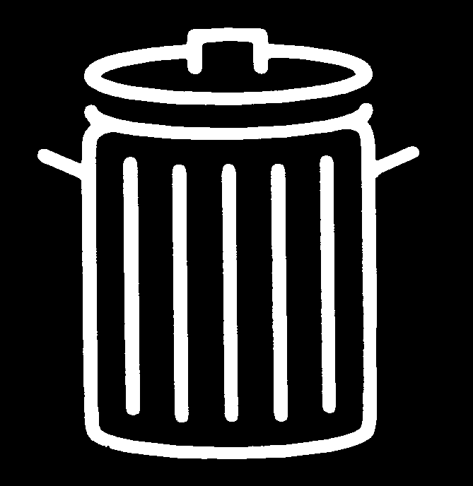 |  | What goes in there?  e.g. ashes, light bulbs, hygiene articles, disposable gloves, candle wax, garbage, small broken objects, carbon paper, leather, porcelain
 |  | What doesn’t?
All organic waste (biowaste), paper, cardboard, glass,
packaging, hazardous waste, bulky waste, wood, metal, aluminum, corks, neon tubes and LEDs

Gray stickers

Green stickers

Blue stickers

Recycling waste (yellow bag) “Gelber Sack“

Packaging Waste
What goes in there?

Empty, rinsed-out packaging (without hazardous substance labels!) and objects made of plastic, metal, aluminum or composite materials, e.g. plastic film, disposable tableware, yoghurt pots, cans, tubes, beverage cartons, takeaway cups

What doesn’t?

Disposable gloves, cannulas, paper / cardboard, glass, organic waste, cork, materials contaminated with chemicals, hazardous waste

Paper / cardboard
“Papier / Pappe”
What goes in there?

Single newspapers, magazines and catalogs, sheets of paper, paper bags, crumpled paper, folded paper and cardboard packaging (no cardboard boxes)

What doesn’t?

Soiled or coated paper, sanitary paper, kitchen paper, cardboard
No stacks of books or magazines

Yellow stickers

... for WASTE PAPER

Waste paper in offices and laboratories is usually collected in blue plastic containers (available from the central Purchasing Office). These may only be used for crumpled paper and not for cardboard.

In the town/ valley area, catalogs, magazines (unless they are the only copies) and cardboard packaging are disposed of directly in the big bins for paper.

Cardboard boxes are taken to the central collection station (usually on the 1st level) at the Morgenstelle campus.

Catalogues, magazines and books must be taken to the Recycling Yard.

The cleaning staff collect the waste paper from the offices and laboratories in big paper sacks. Blue plastic garbage bags are permitted only in exceptional cases - if there is no covered interim storage area.

What goes in the paper waste bin?

E.G.: Letters and envelopes, single magazines, newspapers, paper bags, crumpled paper, writing and note paper, advertising brochures, paper and cardboard packaging (no cardboard boxes)...

What does not go in there?

E.g. soiled paper (grease, paint stains), coated paper, colored napkins, crepe paper, carbon paper and tracing paper (these go in the residual waste), disposable hand towels, kitchen paper and paper handkerchiefs (these go in the organic waste or in the residual waste).

Cardboard packaging must not be disposed of in the bins in the buildings!

... for ORGANIC WASTE

There are usually bins in the corridors for collecting organic waste. These should be lined with paper to make emptying and cleaning easier. In the town/valley area, the cleaning staff empty them into the organic waste bins outside the buildings; on the Morgenstelle Campus, the contents are taken by the waste disposal company to the big organic waste bins at the recycling center.

To avoid unpleasant odors, only containers with lids should be used to collect organic waste.

Organic waste may be used to produce valuable compost; it is of no use in residual waste that is incinerated.

Furthermore, Germany’s circular economy act (Kreislaufwirtschaftsgesetz) has required the separate collection of organic waste since 2015.

What goes in the organic waste bin?

E.g. All organic waste: Fruit and vegetable waste, leftovers, spoiled or moldy food, eggshells, coffee grounds and tea leaves, filter bags, tea bags, small quantities of paper towels, dead houseplants...

What does not go in there?

E.g.: Corks, leather, colored paper (including napkins), cigarette butts and ash, textiles, sweepings, vacuum cleaner bags, rubber, plastic bags, hygiene articles...

... for RECYCLING WASTE recyclables

Special stands for hanging up the yellow plastic recycling waste bags are available from the Central Administration Purchasing office. These may be used for collection in a central location. If this location is in a corridor, the position of the container should be agreed with the Fire Safety office beforehand.

Yellow bags for recycling waste are available from the Purchasing office.

What goes in the recycling (yellow bag)?

All packaging made of plastic, metal or composite materials (with no hazardous substance labels or contamination!), roughly cleaned and without residues.

Please note:

Do not stack packaging materials inside one another if they are made of different materials.
Separate lids from containers made of other materials (e.g. yoghurt pots).
Compress aluminum into fist-sized balls (small parts fall through the grate of the sorting system). (There is a separate collection of aluminum at the University Recycling Yard - the proceeds go to the University).

Compress metal cans at the opening so that they cannot fill up with other materials.

What does not go in the recycling (yellow bag)?

E.g.: Paper/cardboard, glass, cork, disposable syringes, shoes and textiles, residual waste, food waste, packaging with hazardous substance labels.

ENVIRONMENTAL TIPS:

Where possible, reusable packaging should be used.

... for RESIDUAL WASTE
Residual waste is collected in corridors, laboratories and usually also in kitchenettes

What does that include?

E.g.: Light bulbs, hygiene articles, disposable gloves, sweepings, carbon paper, leather, ceramics, vacuum cleaner bags, colored printed paper (including napkins)...

What does not go in there?

E.g.: Organic waste, paper, cardboard, glass, plastics, metal, aluminum, other recyclable materials, hazardous materials.

