

Inclusion of Persons with Disabilities in
Disaster Risk Reduction in Germany

Translated Final Report of the KIM Study

Friedrich Gabel and Maira Schobert

in collaboration with (alphabetically):
Prof. Dr. Regina Ammicht Quinn, Kristína Janačková, Katharina Krause, Dr. Marco Krüger, Friederike Mangeold, Carlina Schreiber, Dr. Markus Spöhrer und Katharina Wezel

Study commissioned by
Aktion Deutschland Hilft e.V. – Germany’s Relief Coalition, Bonn (Germany)

14.10.2024
Content
Executive Summary 4
Foreword Aktion Deutschland Hilft e. V. 5
1. Introduction 6
2. Study scope, objectives, and methodology 7
2.1. Scope and objectives of the study 7
2.2. Methodological approach 7
2.3. Limitations 8
3. Key Findings 9
3.1. Challenges for people with disabilities in disaster management: 10
3.2. Understandings of disability (Indicator 1) 11
3.3. Consideration of persons with disabilities in disaster management strategies (Indicator 2): 12
3.4. Availability of data on the needs and abilities of persons with disabilities (Indicator 3) 13
3.5. Representation of persons with disabilities in disaster management (Indicators 4 and 5): 13
3.6. Existence of trainings and exercises on disaster management as well as inclusive risk and crisis communication (Indicators 8 and 9): 14
3.7. Cooperation between disaster management actors and OPDs and opportunities for meaningful participation of persons with disabilities (Indicators 6 and 10): 15
3.8. Existing measures and investments to reduce barriers in disaster management in Germany (Indicators 7 and 11): 16
3.9. Closing Remarks 16
4. Key Recommendations 18
4.1. Formulation of a cross-actor and cross-departmental strategy for inclusive civil protection 18
4.2. Promote inclusion as an aspect of civil protection and civil protection as an aspect of inclusion 18
4.3. Recognise the diversity of persons with disabilities 19
4.4. Create structures to increase preparedness and self-help capacities of persons with disabilities 20
4.5. Design and conduct more civil protection exercises with persons with disabilities 20
4.6. Enable the provision of data for planning and acute support that protects human rights and complies with the GDPR 21
4.7. Create structures to enable persons with disabilities to contribute to civil protection 21
4.8. Removing barriers in all phases of civil protection 22
4.9. Establish a culture of productive criticism 22
Document Credits 23

Figures
Figure 1: Research Design 8

Abbreviations
ADH Aktion Deutschland Hilft e.V., Germany’s Relief Coalition
CBM Christian Blind Mission e. V.
CRPD (UN) Convention on the Rights of Persons with Disabilities
DGS German Sign Language
GDPR General Data Protection Regulation
OPDs Organisation(s) of Persons with Disabilities
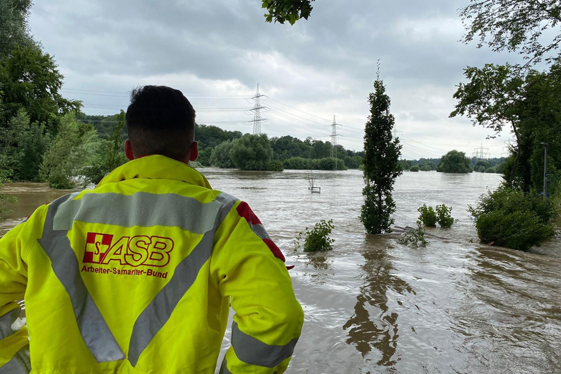
KIM German acronym of the Study „Assessment of disaster management for people with disabilities“ (Bestandsaufnahme zum Katastrophenmanagement und der Inklusion von Menschen mit Behinderungen)
©ASB Bochum

Executive Summary
This report presents the results of a study on the consideration of persons with disabilities, their support needs and abilities in disaster management in Germany (Project KIM). The study was conducted from October 2023 to February 2024 by the International Center for Ethics in the Sciences and Humanities at the University of Tübingen on behalf of Aktion Deutschland Hilft e. V. The study provides findings on eleven indicators based on the Sendai framework. The study also highlights existing potentials and approaches, which have been compiled for the first time in this depth to support the diverse actors in their work. The results of the study provide a starting point for the necessary, systematic examination of the topic of inclusive disaster management.
Key findings include:
- Persons with disabilities face challenges in all phases of civil protection in Germany.
- Persons with disabilities are mostly considered as a mainly vulnerable and homogeneous group that primarily receives support; with little recognition of their potential roles as active participants in emergencies .
- Art. 11 of the CRPD is hardly a topic in both civil protection as well as inclusion strategies.
- There is little data on the situation and needs of persons with disabilities in emergencies.
- It is likely that persons with disabilities are only rarely represented among active personnel in civil protection.
- It is likely that disability or the consideration of persons with disabilities is rarely a topic of trainings for civil protection personnel. Courses to strengthen the self-help capacities of persons with disabilities do exist neither nationwide nor standardised.
- There is only little cooperation between persons with disabilities or OPDs and civil protection actors.
- There exists a variety of approaches and knowledge for considering persons with disabilities in civil protection in Germany. However, they are neither standardized nor commonly known.
These results support the United Nations' assessment of the status of implementation of the
UN Convention on the Rights of Persons with Disabilities in Germany from 2023: This applies in particular to the finding that there has so far been a lack of strategic, cross-actor and Germany-wide structures and approaches to systematically consider people with disabilities, their support needs and abilities. Against this backdrop, the report presents nine recommendations to improve the situation of persons with disabilities in emergencies and their consideration in civil protection in Germany.
- Formulate a cross-actor and cross-departmental strategy for inclusive civil protection.
- Promote inclusion as an aspect of civil protection and civil protection as an aspect of inclusion.
- Recognise the diversity of persons with disabilities.
- Create structures to increase preparedness and self-help capacities of persons with disabilities.
- Design and conduct more civil protection exercises with persons with disabilities.
- Enable the provision of data for planning and acute support that protects human rights and complies with the GDPR.
- Create structures to enable persons with disabilities to contribute to civil protection.
- Removing barriers in all phases of civil protection.
- Establish a culture of productive criticism.
The short report deliberately omits references. For a more detailed presentation of the underlying analysis and sources see the German final report.

Foreword Aktion Deutschland Hilft e. V.
Since its establishment, persons with disabilities, their needs but also their capacities in disaster risk reduction and humanitarian action have been an important topic for the member organizations of Aktion Deutschland Hilft e. V. (ADH). Some of the ADH member organizations have been involved in the Disability-inclusive Disaster Risk Reduction Network (DiDRRN) for many years and are working constantly on improving disability-inclusive disaster risk reduction approaches in various countries. These members also bring their experiences and knowledge into local, national and global advocacy efforts, for example within the UN Convention on the Rights of Persons with Disabilities and especially for the implementation of the Sendai Framework for Disaster Risk Reduction.
Joint learning from operational experiences has always been an important part of ADH´s work. Internal reflections and external evaluations of humanitarian operations, as well as additional studies on key topics are used to continuously improve the humanitarian work of the ADH member associations for the benefit of people affected by crises and disasters. Thus, the proposal from the DiDRRN network to conduct a preliminary study on the level of inclusion of the preparedness phase and the humanitarian response before and after the historic flood event in July 2021 in western Germany (commonly referred to as the “Ahrhochwasser”) was met with great support.
The aim of the study was to commission a cross-stakeholder documentation of operational experiences as well as gaps in inclusive disaster risk management in Germany. The focus was not on the evaluation of disaster relief efforts of aid organizations and authorities in the emergency response phase (reports on these operations are already available from a wide range of institutions). With this stock taking exercise, ADH aims to contribute to a more comprehensive understanding of the needs, concerns, knowledge and capacities related to disaster risk reduction of persons with disabilities in Germany. The study deliberately includes a wide range of actors such as authorities and political decision-makers, , stakeholders and actors working on social welfare, humanitarian organisations, and also people with disabilities and their representative organizations.
ADH would like to express its great appreciation to the study team of the International Center for Ethics in the Sciences and Humanities at the University of Tübingen, led by Friedrich Gabel and Maira Schobert. We would also like to express our gratitude to all those who contributed with their expertise, data and assessments. Finally, special acknowledgement shall be given to the Christian Blind Mission e. V. (CBM) for their support of the translation of the original version into English.
We hope this study provides useful insights, suggestions and concrete ideas to jointly develop a more participatory, inclusive disaster management system in Germany.
On behalf of Aktion Deutschland Hilft e. V.
Manuela Roßbach (Board Member) - Dr. Jürgen Clemens (Advisor)

Introduction
This report presents the results of a study on the consideration of persons with disabilities, their support needs and abilities in disaster management in Germany (Project KIM).
The study was conducted from October 2023 to February 2024 by the International Center for Ethics in the Sciences and Humanities at the University of Tübingen on behalf of Aktion Deutschland Hilft e. V. and published in German in April 2024. The original report(s) including all references as well as list of existing measures and approaches for a (more) inclusive disaster management in Germany can be found here.
The study was prompted by the tragic death of twelve people in a residential home of persons with disabilities in Sinzig, Germany during the flooding on July 14th and 15th 2021, as well as the United Nations' renewed complaint about the inadequacy of the implementation of Article 11 ("Situations of risk and humanitarian emergencies") of the Convention on the Rights of Persons with Disabilities (CRPD) in Germany.
The aim of the study was twofold: firstly, it aimed to improve the data available on the situation of persons with disabilities in disasters and their consideration in disaster management, thereby enabling an assessment of the inclusivity of disaster management in Germany. Due to the large number of actors involved in disaster management in Germany, the situation is complex, and it is often unclear what knowledge, approaches, strategies and initiatives already exist. Secondly, the study aimed to identify starting points for improving existing structures.
With regard to the terminology used in this report: The term “disaster management” was deliberately chosen due to the distinction between protection of the population in disasters (responsibility of the federal states) and protection of the population in time of war (responsibility of the federal government) in Germany. The combination of both aspects is referred to as civil protection. As the study focussed on the protection of the population in disasters and analysed the consideration of persons with disabilities in all phases, from mitigation to recovery, the term disaster management was used.

Study scope, objectives, and methodology

Scope and objectives of the study
Taking into account similar international research, the study raised the question: "To what extent are persons with disabilities, their support needs and abilities currently taken into account in disaster management in Germany?" Eleven indicators were considered to answer this question:
- What understanding of disability underlies the actions of various actors in disaster management?
- To what extent are persons with disabilities considered in strategies for disaster management?
- To what extent are data on the needs and abilities of persons with disabilities available?
- To what extent do persons with disabilities participate in disaster management?
- To what extent do persons with disabilities hold leading positions in disaster management?
- To what extent do opportunities exist for persons with disabilities to shape disaster management?
- To what extent are barriers in disaster management reduced?
- To what extent do strategies, recommendations or trainings exist, which take into account the needs and abilities of persons with disabilities in different phases of disaster management?
- To what extent do strategies, recommendations or trainings for inclusive risk and crisis communication exist?
- To what extent do cooperations between authorities, disaster management actors, organisation of persons with disabilities (OPDs) and care facilities exist?
- To what extent is there a financial investment in inclusive disaster management?

Methodological approach
The KIM-Study combines an empirical data collection and a document analysis.
The empirical data collection comprised individual interviews with experts (n=26), focus group discussions (n=3) and further events with practitioners on the topic (n=2). The interviewees included representatives of the civil protection sector, the welfare sector, various political levels and OPDs. The empirical work was carried out via Zoom and was analysed using qualitative content analysis methods, which were enriched with grounded theory techniques.
For the document analysis, data was collected by performing both a systematic and unsystematic literature study. Additionally, representatives from the civil protection sector, the welfare sector, politics and OPDs were contacted and asked about existing documents (n=370 directly plus approx. n=1,500 via e-mail lists).
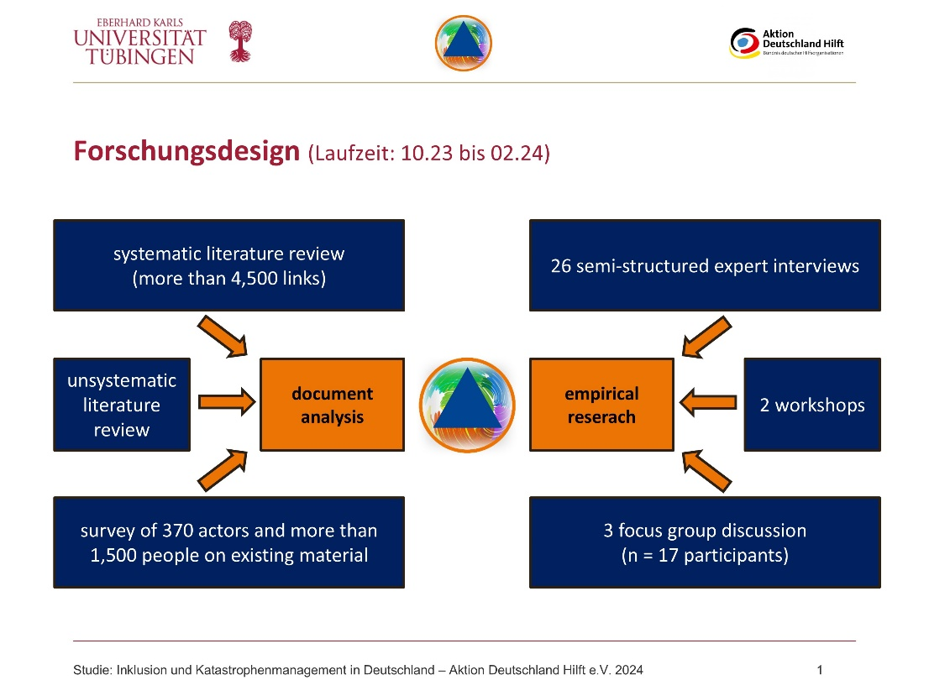
Figure 1: Research Design

Limitations
Limitations of the study are primarily due to the limited time frame of five months. It should be noted that most of the feedback and interview partners came from the states which belonged to the Federal Republic of Germany (BRD) until 1989, far fewer responses came from states that formerly belonged to the German Democratic Republic (DDR). All states were considered equally in the document analysis.
Furthermore, persons with intellectual disabilities or learning difficulties are also underrepresented as direct experts in this study. To counteract this, an attempt was made to include their self-representation organizations as well as representatives.
The study is based on the quality criteria of qualitative research (intersubjective comprehensibility, indication of the research process and appropriateness of the methods, empirical anchoring, limitation, coherence and relevance) and the results are understood as a starting point for the necessary, systematic examination of the topic of inclusive disaster management in Germany.

Key Findings
The results of the study clearly show that persons with disabilities are neither systematically considered nor included in current German disaster management. There is not only a lack of concrete operational plans and concepts, but also an explicit lack of strategies that call for the creation of new concepts or the adaptation of existing ones regarding the support needs of persons with disabilities. Furthermore, persons with disabilities and OPDs are not systematically involved at any level of disaster management. Instead, many interviewees have the impression that the civil protection actors and political decision-makers need to be made aware of the life situations of persons with disabilities in crises and disasters again and again. The complexity of responsibilities in disaster management is often perceived as one of the causes for this situation. The large number of actors involved, and unclear attributions of responsibility prevent a joint, systematic and institutionally anchored approach to inclusive disaster management. In addition, while social or everyday actors see the responsibility for inclusion in disaster management solely with the civil protection actors, civil protection actors see the responsibility for inclusion in disaster management solely with the social or everyday actors. So far, cooperation at federal, state and municipal level has been rare. When it does exist, it is often project-based and rarely transferred into permanent structures. In this regard, reference is often made to funding and personnel deficits that exist both in disaster management and in the area of assistance for persons with disabilities as well as in the care sector. As a result of these inadequate structures, persons with disabilities have to compensate for inadequate deployment concepts and inappropriate equipment in disaster management in addition to the barriers of everyday life. They are often pushed into situations of excessive demands, which cannot simply be attributed to existing impairments, but are rooted in social structures and a lack of consideration. In coping with emergency situations, persons with disabilities are therefore often thrown back on their social environment and dependent on third parties.
The following section presents some specific challenges that persons with disabilities currently face in disasters and with regard to disaster management. Subsequently, assessments of the considered indicators of inclusive disaster management are presented. Due to the many practical overlaps, approaches that focus on older people or people with care needs and their contexts were also considered to some degree. Thereby the report does not include any statements about the quality of existing practices and approaches on inclusive disaster management; such an assessment was not possible as part of the project. In this sense, it should be noted that transferring approaches to persons with disabilities is not always sensible or possible but requires critical examination.

Challenges for people with disabilities in disaster management:
Prevention: For the purposes of the study, disaster prevention includes measures aimed at preventing extreme events or, if they do occur, preventing them from becoming disasters. Everyday barriers (e.g. infrastructural barriers, lack of barrier-free housing, inaccessible local transport, lack of information in plain language or German sign language (DGS) and the often inadequate implementation of the CRPD generally make it difficult for people with disabilities to adequately deal with existing risks. In particular, determining the impact of specific hazardous situations, such as flooding or a widespread power cut, on their own living situations is a major challenge for many respondents. This is also due to the fact that publications regarding individual disaster preparedness are not available across the board. Early warning systems that consider the needs of persons with disabilities have only improved significantly in recent years, although there are still numerous shortcomings. According to the interviewees, the NINA and KatWarn warning apps are still not fully accessible, warning texts are usually not written in plain language and receiving and understanding warnings is often a prerequisite (e.g. possession of a smartphone or internet access, which is not always guaranteed, especially in institutions or facilities for persons with disabilities). Further challenges arise with regard to the NORA emergency call app for persons with hearing and speaking impairments, which currently does not allow new registrations due to widespread misuse of the app for fake emergency calls.
Preparedness: Disaster preparedness is understood here as the acquisition of skills and the creation of capacities (e.g. emergency supplies) to deal with extreme events and disasters. Similar to disaster prevention, there is currently hardly any accessible and low-threshold information available for the context of disaster prevention that relates to the life situation of people with disabilities living independently and the associated precautionary recommendations. Existing information has so far focused in particular on facilities and care contexts. Furthermore, the Federal Government's third report on the participation of persons with disabilities in Germany published in 2021 confirms that the socio-economic situation of persons with disabilities is generally worse than the situation of persons without disabilities. As a result, there is a lack of support structures to enable persons with disabilities to stock up on recommended items, for example. This applies in particular to the purchase of replacement aids and necessary medication. A lack of training, for example in first aid, a lack of safety measures, a lack of plans for the evacuation of (residential) facilities and subsequent emergency accommodation as well as the absence of disaster drills involving persons with disabilities also have a negative impact on existing self-protection capacities.
Relief: For the purposes of the study, disaster relief includes measures for dealing with the consequences of extreme events and disasters. This includes for instance the accessible provision of information or accessible evacuation procedures. In addition to the shortage of nursing staff, assistants and volunteers from civil protection, the infrastructure in disaster management (e.g. insufficient availability of accessible transport vehicles) also makes evacuation more difficult. Furthermore, emergency personnel are often unsure of how to provide assistance to persons with disabilities. There are also differences between different forms of impairment. For example, accessibility for persons with mobility impairments is increasingly being addressed, while other needs, such as support for persons with intellectual disabilities, receive less attention. It is also problematic that assistive devices are not perceived in terms of their importance for individual participation but are often seen as 'luxury goods' (e.g. electric wheelchairs). Accessibility of shelters is so far a recommendation rather than obligatory, even for planned shelters. Therefore, it remains unclear to what extent nursing care and the provision of medical needs can be ensured in the event of prolonged accommodation. In some cases, crisis situations such as the COVID-19 pandemic lead to conflicts between safety and the participation of persons with disabilities. The risk of poorer opportunities for medical prioritization in emergencies was also mentioned as a core issue.
Recovery: Recovery ultimately means all infrastructural, social and individual measures to achieve a new normal after an extreme event or disaster. The consideration of persons with disabilities in recovery measures has hardly been addressed to date. The prompt replacement of aids is essential in order to guarantee social participation again. However, this is currently associated with lengthy bureaucratic processes. Furthermore, the lack of accessible infrastructure and accessible housing is exacerbated by the destruction caused by crises and disasters, as accessibility continues to play a subordinate role in new construction. There are also reports that people with disabilities - especially in institutions - do not have equal access to psychosocial support.

Understandings of disability (Indicator 1)
The current report on the participation of persons with disabilities in Germany from 2021 addresses the problem of a lack of inclusion in all areas of life (e.g. mobility, communication, infrastructure such as buildings, contact with people without disabilities). Based on this study, these findings can also be applied to the area of disaster management. Furthermore, the study clearly found differences in the understanding of inclusion within and between different actors and organisations. This often concerned differences between a one directional integration of persons with disabilities and a multidirectional inclusive approach, which scrutinizes the existing system. In addition, persons with disabilities and OPDs criticize that inclusion is repeatedly focused on as a pure cost factor.
On a different note, the study found perceptions of persons with disabilities which stretch between unreflected attributions of vulnerability and potential helplessness on the one hand and an emphasis on capacities and abilities on the other. The interviewees and OPDs also criticize the fact that people with disabilities are portrayed as suffering and less valuable in various contexts.
Furthermore, persons with disabilities are often perceived as a homogeneous group, which obscures the diversity of their impairments. This goes hand in hand with the fact that disabilities are rarely considered intersectionally: People are focused on one-dimensionally as people with disabilities; their gender, age, any migration background they may have, their socio-economic situation and the interplay of these facets and the resulting specific life-world effects are rarely addressed.

Consideration of persons with disabilities in disaster management strategies (Indicator 2):
The situation with regard to reference to persons with disabilities and possible support needs in disaster management strategies can be described as inadequate and unsystematic.
Links to the consideration of persons with disabilities are mostly found in the strategies of the federal government's work abroad or of foreign aid organizations. Furthermore, aid organizations have been active in international aid for a long time and are committed to inclusive disaster management there. In contrast little of the knowledge and experience is so far transferred to disaster management structures within Germany. The reasons for the lack of consideration of Article 11 of the CRPD in Germany cannot be easily named. However, Article 11 is mentioned in several outward-facing strategies for Humanitarian Aid, which suggests so far it was not considered as of importance for national disaster management.
Domestically, the Federal Government's resilience strategy published in 2022 is a significant step forward, although its significance is unclear due to the complex jurisdictional situation in Germany. With the exception of Rhineland-Palatinate and (to a much lesser extent) North Rhine-Westphalia, people with disabilities are not explicitly mentioned in the state disaster management laws. Article 11 of the CRPD also rarely plays a role in strategies for inclusion on state and municipal level. The report on the participation of persons with disabilities in Germany does not even mention Article 11, although the COVID-19 pandemic and the topic of triage are discussed. A cooperation between the Federal Ministry of Labour and Social Affairs and the Federal Ministry of the Interior on the topic of inclusive disaster management, which was initiated after the 2021 floods, ended with the final report on the floods in 2022. On a positive note, the Telecommunications Act was amended in 2021 and now requires accessibility in warning and emergency calls; however, further steps are required here.
Overall, it also remains unclear who bears and should bear responsibility for inclusive disaster management in Germany. Attributions vary between social actors and social ministries on the one hand and civil protection actors and ministries of interior on the other. In addition, inclusive disaster management is partly described as a cross-cutting task and partly as a topic of activities in the field of psychosocial emergency care.
Ambivalently, it should be noted that in the recent past, the topics of care and the protection of facilities (for persons with disabilities) have received increased attention in disaster management in Germany. This is to be welcomed in principle. At the same time, it must be critically examined to what extent concepts are transferable or whether there are differences between the support needs of persons with disabilities and other groups. Deployment concepts that explicitly take persons with disabilities and their needs into account are still largely at the beginning. In particular, it is for instance not clear to what extent the accessibility of emergency shelters in crises and disasters, at least in planned emergency shelters, can be reliably guaranteed.

Availability of data on the needs and abilities of persons with disabilities (Indicator 3)
The study cannot give a clear answer regarding this indicator. It can be stated that there is little data on persons with disabilities as those affected by emergencies and that this data is even less often disaggregated along age, gender and other characteristics.
Furthermore, there is no database on support needs, locations or capacities for planning and deployment contexts. Difficulties regarding the exchange of data between different actors are seen as a core problem. Thereby, the results of the study suggest that many people with disabilities would generally deposit data in such a database if it would contribute to their safety. At the same time, it would be important for these databases to be accessible and for people with disabilities to be able to decide for themselves (especially if they live in institutions) whether personal data is stored or not. In addition, against the backdrop of increasing right-wing extremist political views in Germany in recent years, many participants are afraid of the data being misused or that further disadvantages follow from such data collections, for instance regarding their insurance coverage. Furthermore, there is no clear opinion as to where such a database should be located.
In addition to databases, interactive maps and situation management tools in which particularly vulnerable facilities can be stored are welcomed and to some degree already exist.

Representation of persons with disabilities in disaster management
(Indicators 4 and 5):
The results for indicators 4 (representation of persons with disabilities) and 5 (persons with disabilities in leadership positions) are presented together due to the proximity of content.
To date, persons with disabilities have rarely been active as helpers in disaster management in Germany. However, this is increasingly being demanded by various stakeholders. In this regard, civil protection actors state that they are generally open for participation. Here, a distinction must sometimes be made between the continued employment of emergency personnel who became impaired as a result of an accident and persons with disabilities who are recruited as civil protection personnel. The first seems to happen more often than the latter. Based on the study data, it appears that persons with disabilities are mainly active in fire departments. It was not possible to assess the situation in the aid organizations. There are hardly any figures in this regard - also for reasons of protection against discrimination. There are probably even fewer persons with disabilities in leading positions.
On a general level, the participation of persons with disabilities is often perceived as challenging. Problems are seen first of all regarding the potential deployment options and their requirements. In this regard the authors refer to two perceptions: On the one hand, discussions on an involvement of persons with disabilities does often only focus on activities in the front row (e.g. as a paramedic) but neglect other back services. On the other hand, actors seem to understand requirements for participation in civil protection as sole criteria for persons with disabilities. Thereby, for every volunteer and member of civil protection personnel there needs to be a fit between person and position. Adding to this, another frequently cited problem is seen regarding the insurance coverage. Although insurance companies argue that they are open for a participation of persons with disabilities and happy to help enable people with disabilities to work, practitioners argue that persons with disabilities would not get proper insurance for their work; which leads to exclusion. In practical terms, problems exist because persons with disabilities receive little information about participation opportunities, and information campaigns like “mit-dir-für-uns-alle” (“with you for us all”) by the Federal Office of Civil Protection and Disaster Assistance – which highlights examples of persons with disabilities in leading positions in civil protection – have received little attention. Also, reference is made to infrastructural barriers, for example in the properties of the civil protection actors, which the individual organizations cannot easily remove on their own. Finally, persons with disabilities are also often solely seen as recipients of help and not providers. If they want to become active as aid providers themselves, they face numerous barriers (e.g. everyday barriers and disadvantages or a lack of accessibility to training).
At the same time, according to the interviewees, greater involvement of persons with disabilities is seen as a valuable goal, for instance to bring expertise for inclusive disaster management in-house.

Existence of trainings and exercises on disaster management as well as inclusive risk and crisis communication (Indicators 8 and 9):
Due to the proximity of content, the results for indicators 8 (training/education on disaster management) and 9 (training/education on crisis communication) are presented together. By way of classification, it should be mentioned that the study only found training courses that had a relevant title or explicitly named disability or the consideration of persons with disabilities as a topic. In this sense, it is possible that programs that did not have a relevant title but nevertheless address this topic were not considered. Furthermore, besides the existence of these courses, little can be said about their accessibility or participation of persons with disabilities (as lecturers).
According to the existing data, training regarding the topic of disability or the consideration of persons with disabilities is primarily found in police forces. At least, the requirements mentioned in inclusion strategies of state and municipal level suggest that there are already offers here. The situation for fire departments is more ambiguous. The availability of materials suggests that persons with disabilities and their support needs are addressed in training courses. Reports from personnel on the other hand indicate that training courses are rare. The situation in the aid organizations such as the Deutsche Rote Kreuz, the Arbeit-Samariter-Bund, the Malteser Hilfsdienst, the Johanniter Unfallhilfe or the Deutsche-Lebens-Rettungs-Gesellschaft is even less clear. There are some contexts in which disability is addressed. However, there is no evidence that it is standard part of trainings of civil protection personnel. At federal level, the Federal Academy for Civil Protection and Civilian Defense (BABZ) offers one course related to the consideration of persons with disabilities. In the recent past, there have been increasing calls for the strengthening of self-help capacities and the inclusion of persons with disabilities in the emergency services.
Despite the likely lack of comprehensive courses on disabilities and the inclusion of persons with disabilities in civil protection structures, the study found no indication that persons with disabilities are actively excluded from participating in training for the general public. At the same time, they are often passively confronted with infrastructural and communication-related barriers that can prevent participation. The participation of persons with disabilities in such trainings is often dependent on the willingness of local trainers and examiners.
Specific first aid courses for persons with disabilities do exist in various places, but only sporadically and with a focus on different impairments. Other training courses, such as regarding fire safety, are aimed more at residents of institutions or at relatives of persons with disabilities.
Regarding the involvement of persons with disabilities in civil protection exercises the interviewees (especially those from civil protection) report that persons with disabilities are very rarely involved, neither in the execution nor the planning.

Cooperation between disaster management actors and OPDs and opportunities for meaningful participation of persons with disabilities (Indicators 6 and 10):
Due to the proximity in terms of content, the results for indicators 6 (opportunities for people with disabilities to participate in shaping the future) and 10 (cooperation between disaster management actors and self-advocacy organizations [OPDs]) are presented together.
There are currently only a few collaborations between persons with disabilities or OPDs and actors from the civil protection sector. However, depending on the body or person interviewed, there are different perceptions as to whether this is seen as (in)appropriate. Existing collaborations are often of a project nature, and it is not clear whether the results can have a long-term impact. They also focus primarily on institutions or relatives and not on persons with disabilities and OPDs. Commitment is also often dependent on individual persons and agencies. Along with this, persons with disabilities and OPDs are rarely involved in the design of security measures. This is even more important from an intersectional perspective, as for example persons with disabilities with a migration background, tend to become fully invisible.
The main reason given by persons with disabilities for the lack of cooperation is a lack of awareness regarding potential extreme events such as disasters. This is also reflected in the inclusion strategies, in which civil protection is barely addressed. In addition, participation processes are often intended to be unpaid, which is often difficult for the mostly voluntary and/or non-profit OPDs. Finally, interviewees argued, that civil protection actors partially do have negative attitudes towards individual initiatives by persons with disabilities and OPDs. Reasons for the lack of cooperation which are given by civil protection actors include the costs associated with measures to ensure accessibility.

Existing measures and investments to reduce barriers in disaster management in Germany (Indicators 7 and 11):
Due to the proximity of content, the results for indicators 7 (reduction of barriers) and 11 (investments in inclusive disaster management) are presented together.
Despite the problems outlined so far, it can be stated that there are certainly some approaches and materials that address aspects of inclusive disaster management. However, there is often a lack of knowledge about which approaches and measures already exist, even within the organizations that have published those. Also approaches and materials do not exist across the board or in a standardized form. In this sense, it cannot be assumed that living conditions throughout Germany are equivalent. The existence of structures rather depends both positively and negatively on individual commitment and individual willingness.
Many existing approaches and materials focus on care settings and care recipients and persons with disabilities who live in disability care facilities. This is another reason why the existence of such approaches and materials says little about whether persons with different forms of impairment who live independently outside an institution can also benefit from them.
Progress regarding the consideration of persons with disabilities in civil protection structures in Germany can be found in particular in the areas of fire protection, heat protection and the removal of barriers in the warning system. The project “Laboratory 5.000” funded by the Federal Office of Civil Protection and Disaster Assistance, which involves the creation of materials and operating concepts for the accommodation of up to 5,000 people in emergency situations, has great potential to further advance these approaches. The way in which persons with disabilities are taken into account here could have special signal effects for other deployment concepts.

Closing Remarks
The KIM-study shows the challenges that persons with disabilities currently face in disaster situations in Germany. The findings support the United Nations' statement that there is currently a lack of strategic considerations and actions in Germany as to how persons with disabilities can be adequately considered and included within the meaning of Article 11 of the CRPD. Without active and full implementation of Article 11, it cannot be assumed that the (human) rights of persons with disabilities will be guaranteed in disaster situations.
Although promising measures and approaches to consider and support persons with disabilities in disaster situations already exist, whether a person or their living situation is considered heavily depends on where they live. This applies to all phases of disaster management. What was not found are signs for active discrimination against person with disabilities. Helpers and those in charge emphasize that they will try to save everyone, but that they have to improvise. The fact that individuals have the awareness and commitment to act appropriately for everyone in the event of an emergency in Germany is to be highly valued. This also applies to people with disabilities who, due to a lack of existing support structures, have to develop alternative ways of acting in order to rescue themselves from dangerous situations and sometimes even take care of themselves. At the same time, the reliance on the improvisational skills and behaviour of individuals show that support structures especially with regard to planning do not exist in a sufficient manner. Consequently, the study emphasises a need for action at all levels and by all actors – not only in disaster management or civil protection, but also by social actors and social ministries.
This criticism of the current situation should be seen as an opportunity to identify problems and thus design both structures and courses of action before the next extreme event occurs. With this in mind, the aim should be to repeat similar studies at regular intervals to make progress visible.

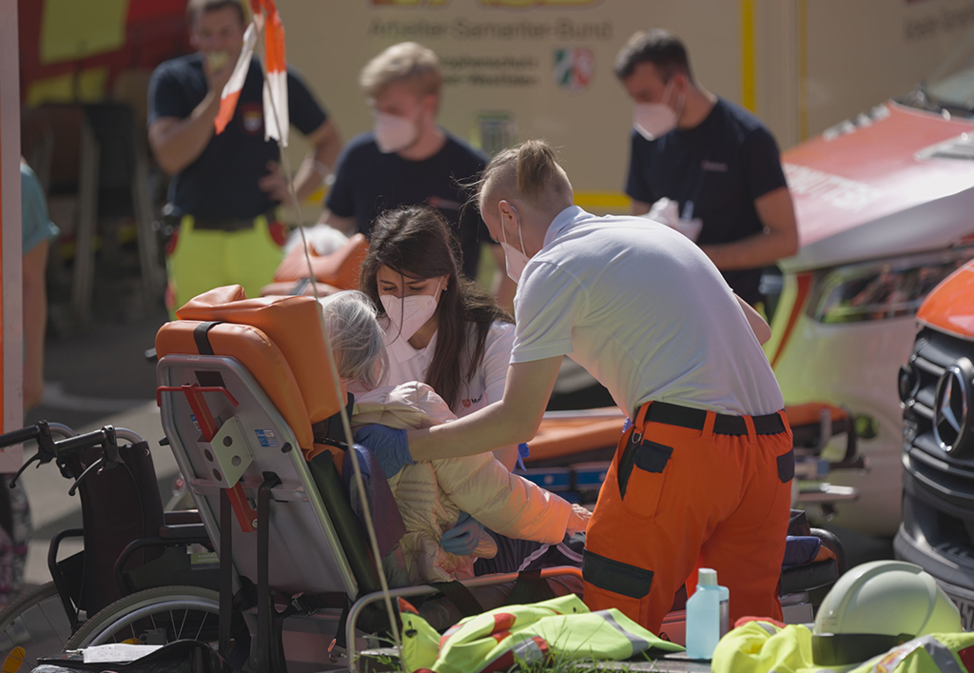
©Aktion Deutschland Hilft/ich.tv

Key Recommendations
Based on the results of the study, nine recommendations and subsequent actions for improving the inclusiveness of civil protection in Germany were formulated. These are based on the indicators of the study and address existing problems. In order to support stakeholders in implementing these recommendations, all measures, guidelines, recommendations, checklists, training concepts and research reports identified in the project were compiled in the German version of the final report.

Formulation of a cross-actor and cross-departmental strategy for inclusive civil protection
Effective civil protection addresses all people equally and considers their specific needs. This requires a coordinated and jointly supported plan with clear responsibilities and common standards to ensure equal living conditions regardless of where people are located. Such strategy should combine the currently distinguished areas of civil protection in disaster related scenarios (in jurisdiction of the Bundesländer [states]) and civil protection in war related scenarios (in jurisdiction of the Bund [federal state]). (Indicators 2, 6 and 10)
- Formulate a strategy for inclusive civil protection in Germany that includes goals, steps, a timeline, responsible actors as well as indicators and review bodies to assess success.
- Involve persons with different forms of impairment in all steps of this process, especially as decision-makers.
- Create a national focal point for information, materials and approaches on inclusive civil protection measures.
- Promote efforts to collect, process and use of existing knowledge and approaches from Germany and abroad for the creation of the strategy and concrete steps.
- Promote efforts to learn from previous events and adjust concepts and strategies.
- Strengthen research funding for inclusive civil protection.

Promote inclusion as an aspect of civil protection and civil protection as an aspect of inclusion
Article 11 of the CRPD has so far received little attention in Germany, both in civil protection and in the contexts of inclusion action plans. To achieve this, civil protection and the implementation of inclusion must be more closely linked. Civil protection does not just begin in the event of a disaster or a crisis but builds on everyday structures. Inclusion is not only important in everyday life but must also be practiced in emergencies. (Indicators 2, 6 and 10)
- Promote the implementation of the CRPD at all levels and remove barriers to build capacities for coping with emergencies in everyday life.
- Reflect on the potential implications of civil protection measures and approaches for persons with different forms of impairment.
- Create permanent and funded positions for the implementation of the strategy for inclusive civil protection at federal, state and municipal level, as well as in interior and social ministries.
- Involve persons with different forms of impairment in processes for the design of crisis plans at federal, state, municipal and facility level; especially as decision-makers.
- Enable the participation of volunteers from OPDs through expense allowances and other measures.
- Ensure the inclusion of a disability-related perspective in all phases of crisis and disaster management.
- Establish contact points to advise independently-living people with disabilities on civil protection, including self-preparedness measures and participation options.
- Involve civil protection actors in the (re)construction and implementation of climate adaptation measures. This is particularly relevant for facilities for persons with disabilities.
- Promote cooperation between civil protection actors, self-advocacy organizations, welfare actors and operators of institutions for persons with disabilities.
- Strengthen sanction mechanisms for neglecting the needs of persons with disabilities and failing to implement the CRPD (e.g. accessibility) also in civil protection.

Recognise the diversity of persons with disabilities
Persons with disabilities are no homogeneous group. Like other parts of the population, there are not only differences in terms of the existing forms of impairment and their severity, but also in terms of different living situations and realities. Measures should always be matched to specific living situations of persons with disabilities. In addition to their physical, intellectual, sensory and psychological condition, persons with disabilities do also have a gender, an age, a migration background, a social status, a certain social environment and other characteristics. These factors influence individual capacities and challenges in extreme events. These intersectionalities must be considered when designing and implementing civil protection measures. (Indicator 1)

- Recognise and consider the physical, intellectual, sensory and psychological diversity in concepts and deployment strategies for civil protection.
- Recognise and consider assistive devices as a prerequisite for appropriate participation of persons with disabilities (also in disasters and times of war).
- Recognise and promote a self-determined life for persons with disabilities outside of institutions.
- Adjust concepts and measures for civil protection to the living situations of persons with different forms of impairment.
- Scrutinize the German civil protection principle of "clean. saturated. safe." against appropriate participation and equal care for persons with disabilities.
- Scrutinize the narrative of “vulnerable groups”: Social action influences who becomes vulnerable. The more inclusive the structures, the lower the vulnerability.
- Promote a critical and transparent debate on similarities and differences regarding the support needs of older people, care recipients and persons with disabilities.
- Include persons with different forms of impairments in all processes; especially as decision-makers.

Create structures to increase preparedness and self-help capacities of persons with disabilities
The abilities to prepare and self-help are important components of successful civil protection. Like the rest of the population, persons with disabilities have a wide range of abilities. Persons with disabilities also have the same duty to contribute to civil protection within the scope of their abilities. Currently many barriers prevent persons with disabilities from using these abilities and push them into a state of helplessness and dependency. Persons with disabilities must be enabled and empowered so that they can take precautions, help themselves and others. (Indicators 1, 4, 8 and 9)
- Create accessible training courses on existing risks and appropriate associated actions for persons with disabilities and their relatives that consider the living situations of persons with various forms of impairments.
- Ensure a nationwide availability of first aid and fire safety courses for persons with various forms of impairments living in institutions or independently.
- Involve persons with various forms of impairments as instructors and promote accessibility measures for the courses.
- Create easily accessible brochures on existing risks and associated courses of action that consider the living situations of persons with various forms of impairments.
- Establish contact points and support services for persons with disabilities to assist with individual preparedness activities, considering the role of health insurance companies and care insurance funds.
- Discuss the provision of a hotline for people with special support needs in emergency situations beyond (emergency) medical assistance.
- Remove barriers in early warning, emergency calls, evacuation, emergency accommodation and recovery efforts that prevent persons with disabilities from acting independently; create inclusive redundancies for these measures.
- Include persons with different forms of impairments in all processes; especially as decision-makers.

Design and conduct more civil protection exercises with persons with disabilities
For something to be retrievable in an emergency, it must be practiced beforehand. Currently there is a lack of inclusive civil protection exercises. This not only risks triggering fears of contact butalso hinders the identification of inappropriate designs and structures. An inclusive exercise culture is essential for all types of emergencies. (Indicators 8 and 9)
- Include persons with different forms of impairments in the design processes of civil protection exercises; especially as decision-makers.
- Include persons with different forms of impairments in civil protection exercises; especially as decision-makers.
- Analyse all exercises (with persons with disabilities) and formulate lessons learned.

Enable the provision of data for planning and acute support that protects human rights and complies with the GDPR
The capacities of civil protection actors are limited and the predominantly volunteer-based German civil protection system requires a start-up time before assistance ca be providedTo provide help quickly and effectively, information is needed on who needs help, when and where. It is crucial to ensure that the persons behind this data are protected from a misuse of this data and anti-disability actions. (Indicator 3)
- Discuss options for a database on persons with different support needs transparently, considering existing approaches and tensions between data protection and the potential of misuse.
- Create cross-organizational and cross-state deployment routines for providing assistance to persons with different forms of impairments.
- Promote network activities between civil protection actors, self-advocacy organizations, welfare actors and operators of institutions for persons with disabilities.
- Include persons with different forms of impairment in all processes; especially as decision-makers.

Create structures to enable persons with disabilities to contribute to civil protection
Civil protection is a task for society as a whole, to which everyone can and should make a contribution. So far persons with disabilities are rarely active in civil protection in Germany neither on a voluntary nor full-time basis. Improving this situation can not only address the decline in the number of volunteers, but also enable valuable contributions to more inclusive civil protection, leveraging their knowledge of support needs and diverse living situations. At the same time, if persons with disabilities are to participate, existing barriers must be removed and persons with disabilities have to be enabled to fully use their capacities. (Indicator 4)
- Inform persons with disabilities about the possibilities and necessity of participating in civil protection and raise awareness of the variety of fields of activity and requirements.
- Remove infrastructural and mental barriers of civil protection actors that prevent participation and minimize reliance on the willingness of individual executives.
- Promote accessibility measures by discussing the extension of health and care insurance subsidies to support participation in civil protection activities.
- Involve and empower persons with disabilities as first responders in the facilities where they live and work.
- Include persons with different forms of impairments in all processes; especially as decision-makers.

Removing barriers in all phases of civil protection
Removing barriers is central to inclusive civil protection. Current efforts mainly focus on warning. At the same time, accessibility and the consideration of persons with disabilities and their support needs must be integrated into all phases: prevention,preparedness, response and recovery. (Indicator 7 and 11)
- Gather requirements concerning the support needs of persons with disabilities across all phases of civil protection.
- Raise awareness and train civil protection workers for the support of persons with disabilities, older persons and care recipients, especially in non-medical support.
- Advocate for an increase in the number of night patrols in facilities that provide assistance to persons with disabilities.
- Establish structures to prevent a decline in participation and loss of therapy services during crises.
- Ensure sign language interpretation and plain language for warnings for extreme events are available across all public channels (not just digital ones).
- Establish mandatory and uniform standards to ensure equal participation for persons with different forms of impairments in emergency shelters (e.g. through accessibility, replacement of aids and trained staff).
- Ensure improved protection against (sexual and gender-based) violence in emergencies.
- Ensure a transparent discussion about tensions between triage and disability.
- Adapt building regulations to ensure that all new buildings, including those in reconstruction, are accessible and that destroyed accessible housing is replaced.
- Include persons with different forms of impairments in all processes; especially as decision-makers.

Establish a culture of productive criticism
Both civil protection and inclusion face complex challenges, and they can sometimes conflict with each other. In such situations, it is crucial to find solutions that adequately address the needs of persons with different forms of impairments while also considering the challenges faced by civil protection actors. On the one hand, this requires that persons with disabilities and their support needs are not dismissed as extra effort but are integrated as a core aspect of civil protection measures. On the other hand, there needs to be mutual understanding of the existing challenges and a certain level of respect for diverse living situations. (all indicators)
- Create an atmosphere of respectful and productive cooperation between civil protection actors and persons with disabilities for their mutual benefit.
- Ensure that the human right to equal participation does not end in emergencies.
- Recognise that tensions between security and participation in inclusive civil protection cannot always be prevented but must be made transparent and accepted.
- Promote an all-round willingness to learn and continuously improve from shortcomings.

Document Credits
Inclusion of Persons with Disabilities in Disaster Risk Reduction in Germany
Translated Final Report of the KIM Study
Study commissioned by:
Aktion Deutschland Hilft e.V. – Germany’s Relief Coalition, Bonn (Germany)
Original Authors:
Friedrich Gabel and Maira Schobert
(International Center for Ethics in Sciences and Humanities, Eberhard Karls University Tübingen)
Study team / contributors (alphabetically):
Prof. Dr. Regina Ammicht Quinn, Kristína Janačková, Katharina Krause, Dr. Marco Krüger, Friederike Mangeold, Carlina Schreiber, Dr. Markus Spöhrer und Katharina Wezel
Editor:
Aktion Deutschland Hilft e.V. – Germany’s Relief Coalition, Bonn (Germany)
Translated by:
Christoffel-Blindenmision – Christian Blind Mission e.V. (CBM)
Cite as:
Gabel F., Schobert M. (2024): Inclusion of Persons with Disabilities in Disaster Risk Reduction in Germany Translated Final Report of the KIM Study, Ed. Aktion Deutschland Hilft e.V. – Germany’s Relief Coalition, translated by Christian Blind Mission e.V., Bonn.
Logo: Cover image and project logo were created based on the free image license of starline on Freepik
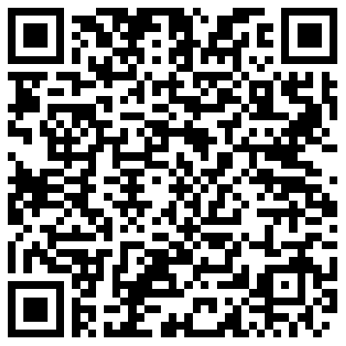
Original project results in German language:
https://www.aktion-deutschland-hilft.de/de/wir-ueber-uns/evaluierungen/studie-katastrophenmanagement-inklusion/

See for instance CBM e. V., ASB e. V., MI, CDD, & IDA (Ed.) (2022): Including Persons with Disabilities in Disaster Risk Reduction: A Research Study from Eight Countries of Africa, Asia and South/Central America, Supported by the DiDRRN, URL: https://reliefweb.int/report/world/including-persons-disabilities-disaster-risk-reduction-research-study-eight-countries-africa-asia-and-southcentral-america.
Disaster management in Germany represents but one part of civil protection. While disaster management lies in the jurisdiction of the Bundesländer (states), protection of the population in times of war lies in the jurisdiction of the Bund (federal state). Although the study focussed on disaster management, due to overlaps in personnel and structures, there are reasons to believe, that many findings hold true for civil protection in times of war too.

